Course 2 - pre course

Dear Participants

Please make sure to accurately complete steps 1 and 2 before our training program commences on July 24th. If you have any queries or issues, feel free to reach out to support@settlemint.com.

Congratulations 🥳🎉 You have been assigned to team **{ Cloud provider - Region }**

We're thrilled to welcome you to our Blockchain Training Program.This is a fantastic opportunity to elevate your skills amidst the exponential growth of blockchain adoption across various industries.

**Before you delve into the training program**, we've created some important steps for you to get you started.

**Getting Started:**

**Step 1: Sign Up**

Please refer to the attached PDF named "Registration" to complete your registration following the provided guide. It is important that you fill out every detail correctly to avoid any errors.

**Step 2: Prepare Your Environment**

As part of this training program, you have been assigned to teams. Each team is associated with a specific cloud provider, on which all your blockchain services will be deployed.

You have been selected for Team **{ Cloud provider - Region }** , which means you will deploy all your

services using the following deployment plan (refer to step 3/2 in the image below):

Type: **Shared**Cloud Provider: **{Cloud provider }**Region: **{ Region }**

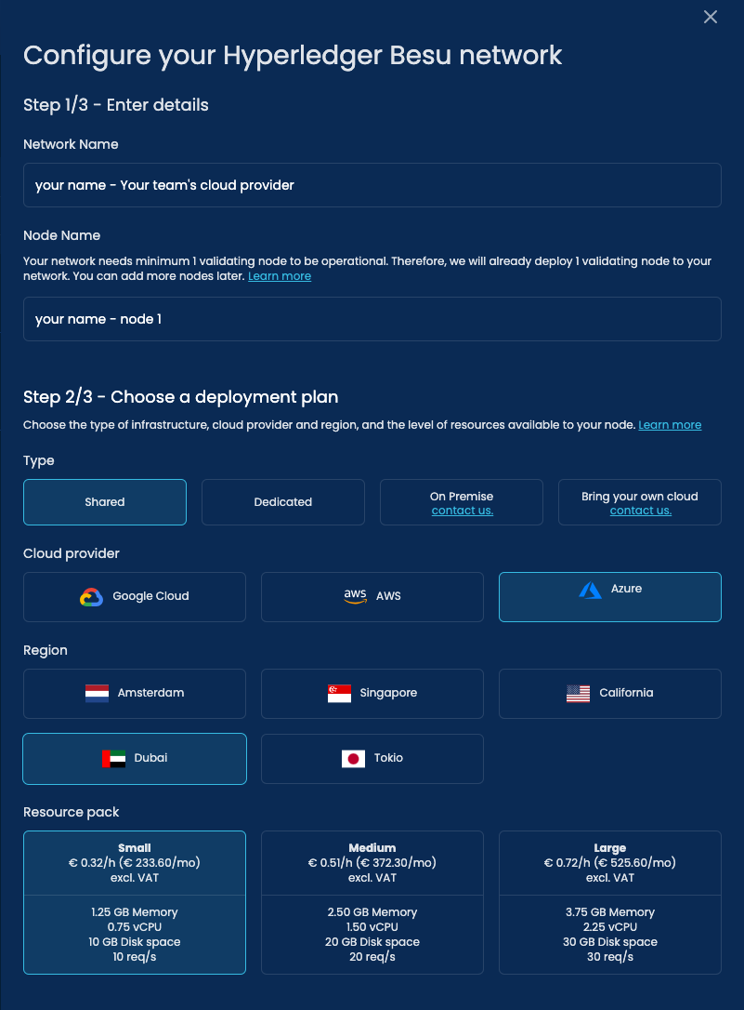

1. Create an app  
     
     
   Inside the "OCBC Training Program" workspace, click "Create Blockchain Application" to begin.

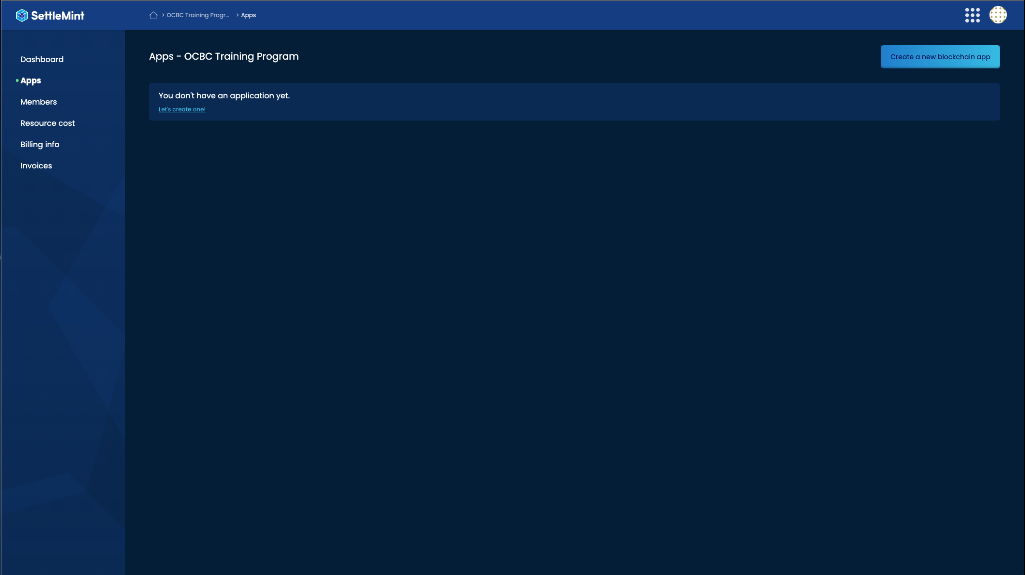

1. Configure your application with your name and the assigned cloud provider.   
     
   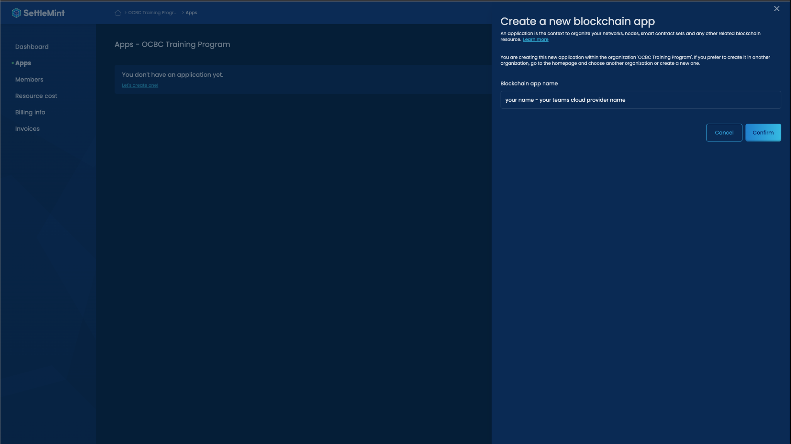
2. You will see the following page   
     
   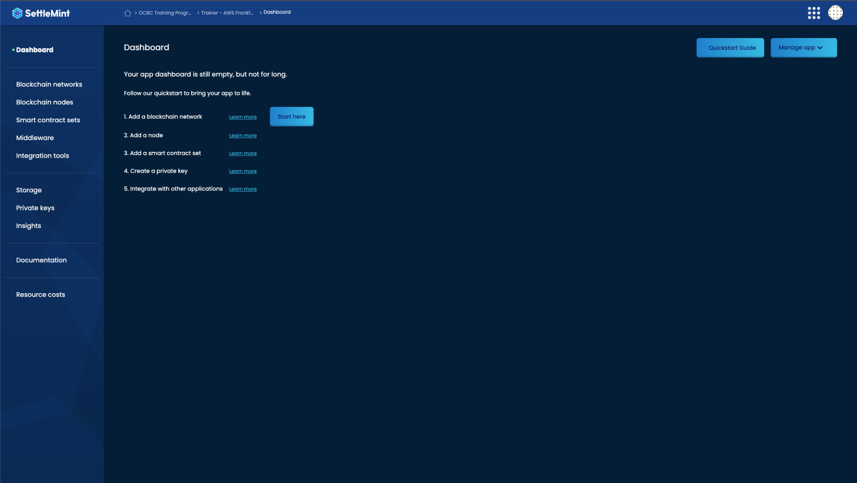
3. From there, navigate to "Blockchain Networks" and click on "Add Blockchain Network". Select "Hyperledger Besu" from the options provided.

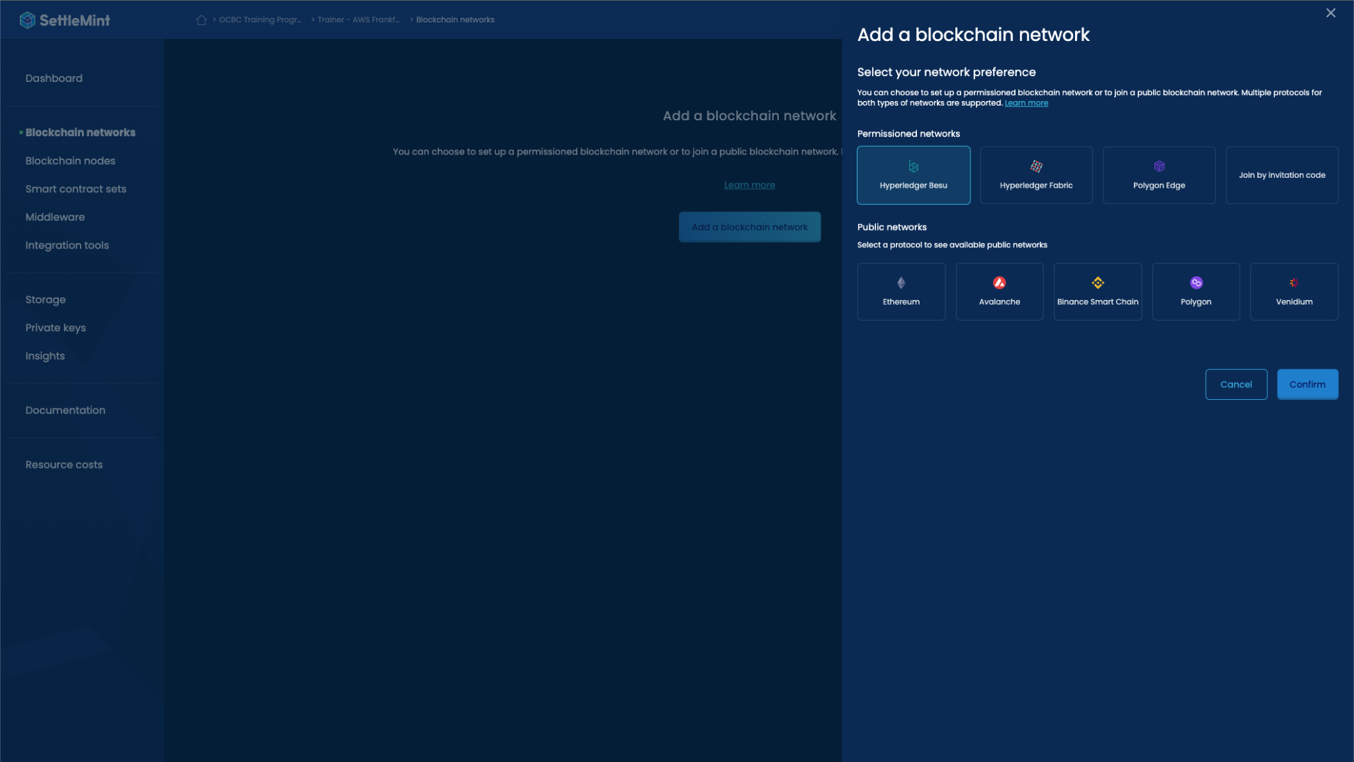

1. Choose the cloud deployment option according to your assigned team. For this example, participant “Trainer” is assigned to "AWS Frankfurt," so he will deploy all the services with the following settings:  
     
     
    Type: Shared

Region: Frankfurt

Resource Pack: Small

Cloud Provider: AWS

In the screenshots below, we are using 'AWS-Frankfurt' to deploy. Please use the cloud provider and location you have been assigned. This is found on page 1 and in the email you received. If you have any questions, contact [support@settlemint.com](mailto:support@settlemint.com) or saeed@settlemint.com

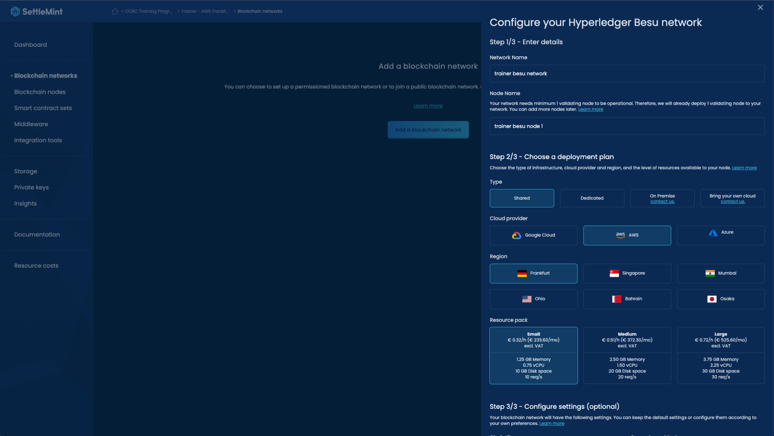  
  
You can now view the blockchain node that you just deployed in the "Blockchain Nodes" tab. Once the status of your node is "Running," you can proceed to step 6.

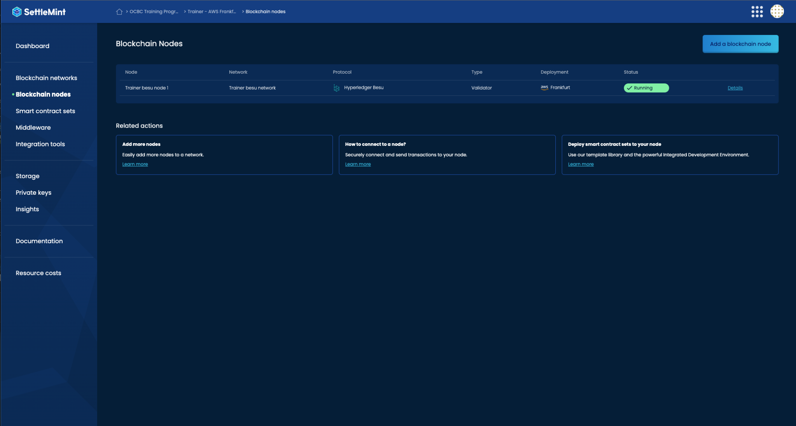

1. Next, let's deploy a smart contract set. The process is very similar to step 5:

A. Navigate to the "Smart Contract Sets" tab in your left menu.

B. Click on the "Add Smart Contract Set" button.

C. In the first section, "Choose Template," select the "ERC-20 Token" template.

For the remaining settings, choose the same options as you did in step 5:

Type: Shared

Cloud Provider: Your assigned cloud provider

Region: Your assigned region

Resource Pack: Small

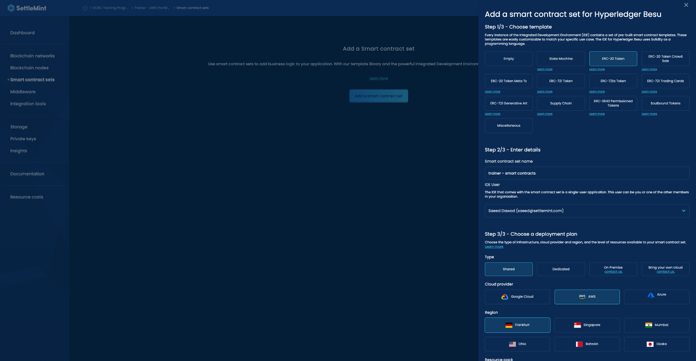

Click "Confirm". Once your smart contract set is in the "Running" status, you are ready to proceed to step 7.   
  
In this step, you will deploy your own Interplanetary File System (IPFS) node.

1. To deploy your own IPFS node, follow these steps:

A. Navigate to the "Storage" tab in the left menu.

B. Click on the "Add Storage" button.

C. Select "IPFS" as the storage provider and configure the remaining settings similar to what you did in steps 5 and 6, based on your selected team's cloud provider:

Type: Shared

Cloud Provider: Your assigned cloud provider

Region: Your assigned region

Resource Pack: Small

Once you have completed these steps, your IPFS node will be deployed

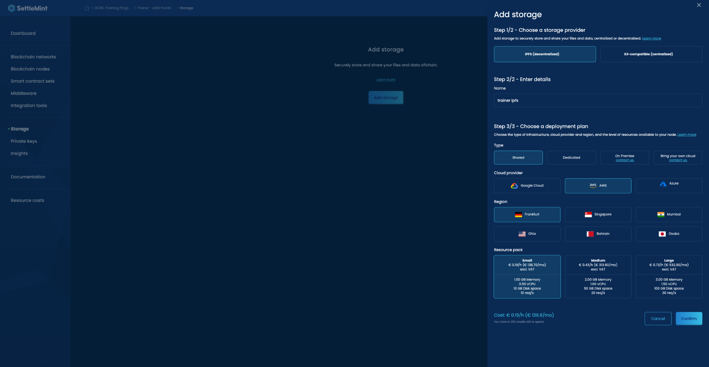  
  
Once your IPFS node status is “running” move on to the next step! We are almost done  
  
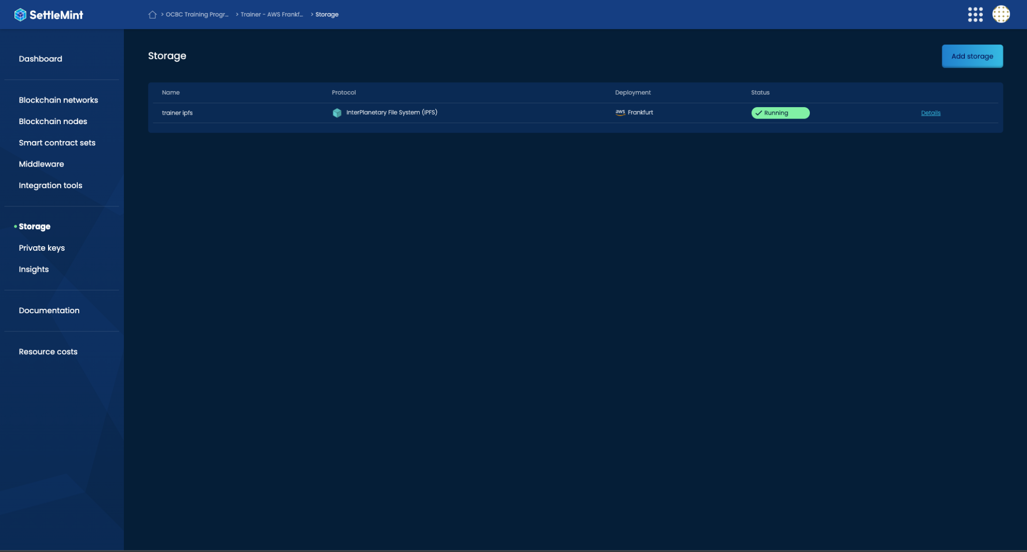

1. To deploy the Graph Middleware, please follow these steps:

A. Navigate to the "Middleware" section in the left menu.

B. Click on the "Add Middleware" button.

C. Select "Graph Middleware" from the available options. Deploy it with the same settings you used when deploying the other services, including your team's cloud provider, region, and a small resource pack.

By following these steps, you will successfully deploy the Graph Middleware.

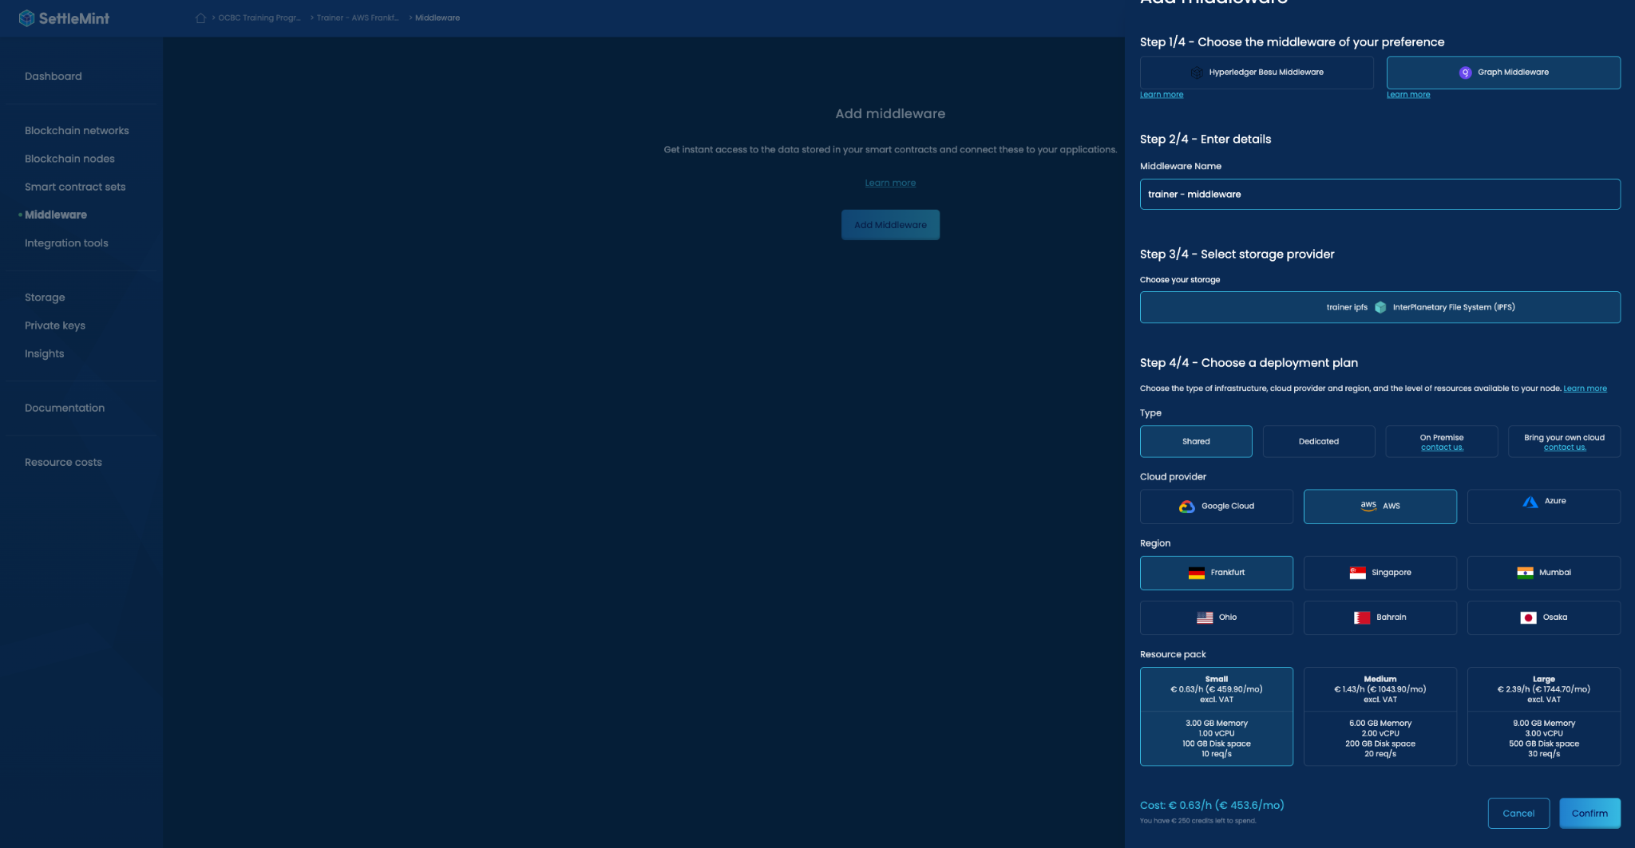  
  
Once the Graph Middleware status shows as "Running," you are free to proceed to the next step.



1. To deploy the Integration Studio, please follow these steps:

A. In the left menu, select "Integration Tools."

By now, you should have become a blockchain deployment expert!

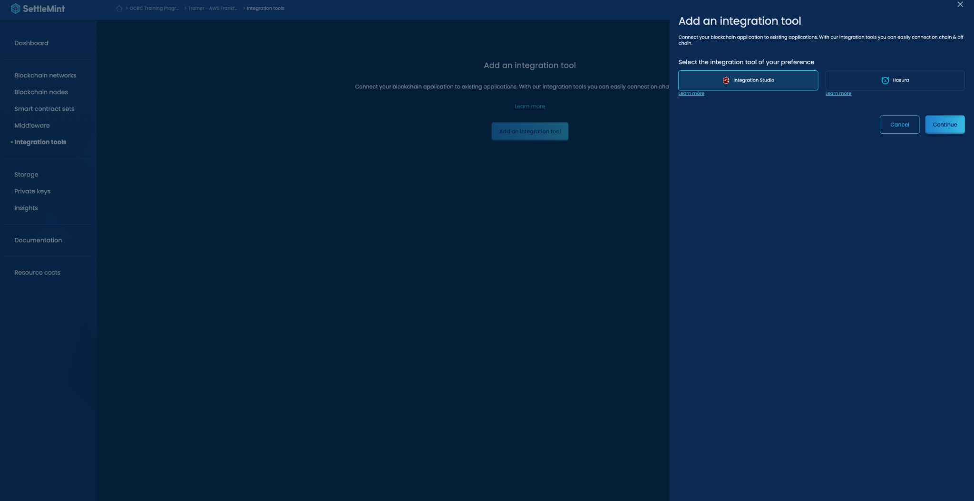  
  
  
B. Select integration studio

C. Deploy it according to the team settings that you have been assigned to.

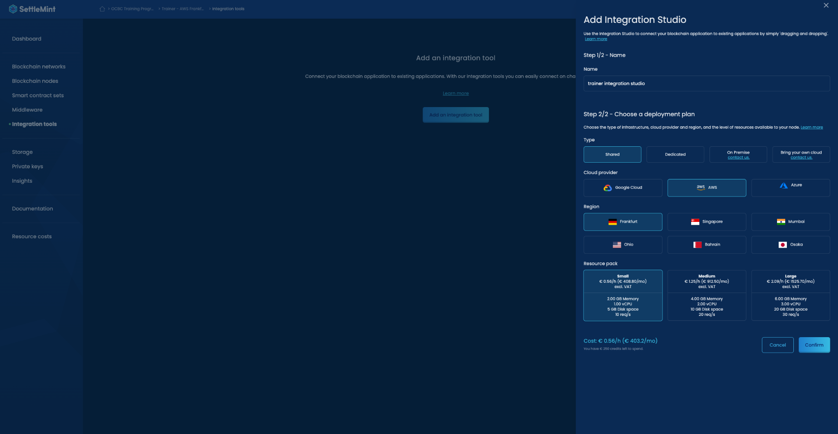  
  
Once it is ready, we will proceed to deploy Blockscout. Blockscout will provide you with a graphical user interface (GUI) to view the blockchain that you have deployed.

Please follow the next steps to deploy Blockscout.

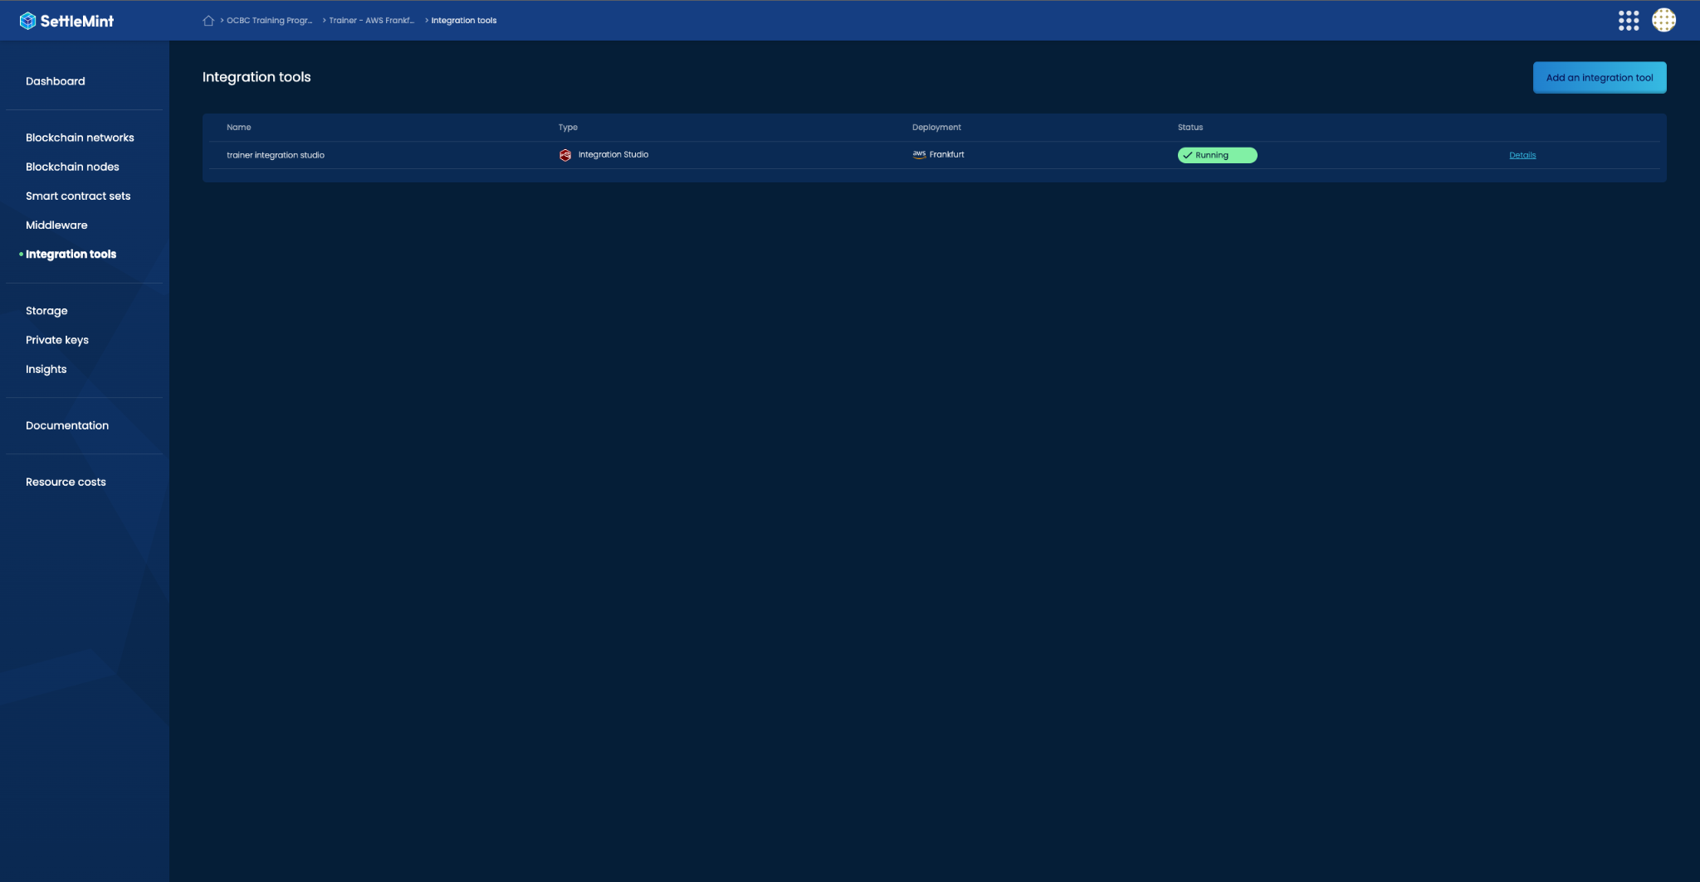

1. To deploy Blockscout, please follow these steps:

A. Click on "Insights" in the left menu.

B. Choose "Blockscout" and select the node that you have deployed.

By following these steps, you will successfully deploy Blockscout and be able to access the insights and information about your deployed blockchain node.

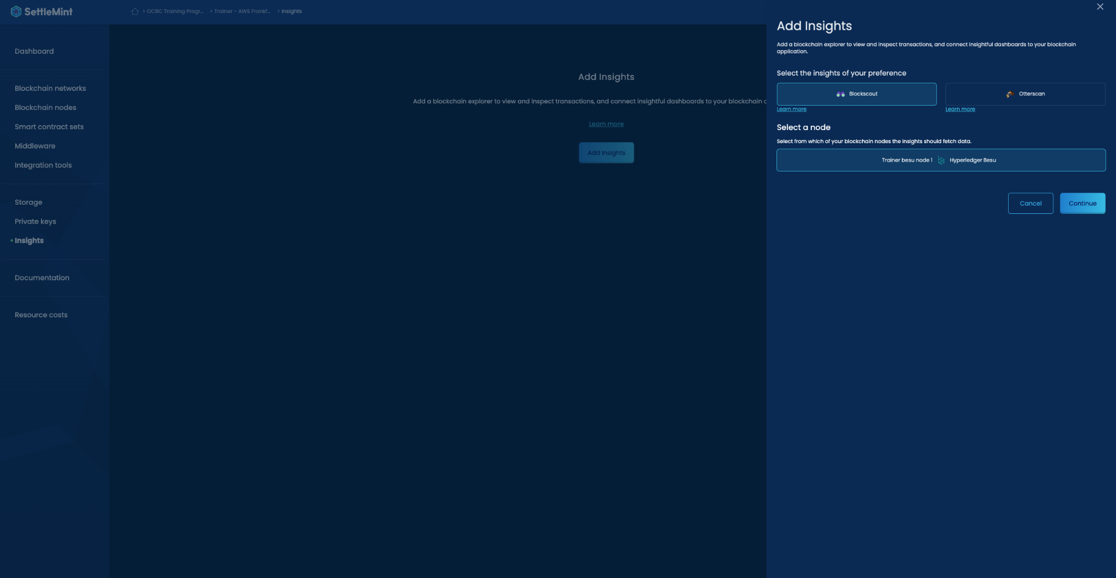  
  
C. pick the deployment settings according to your team  
  
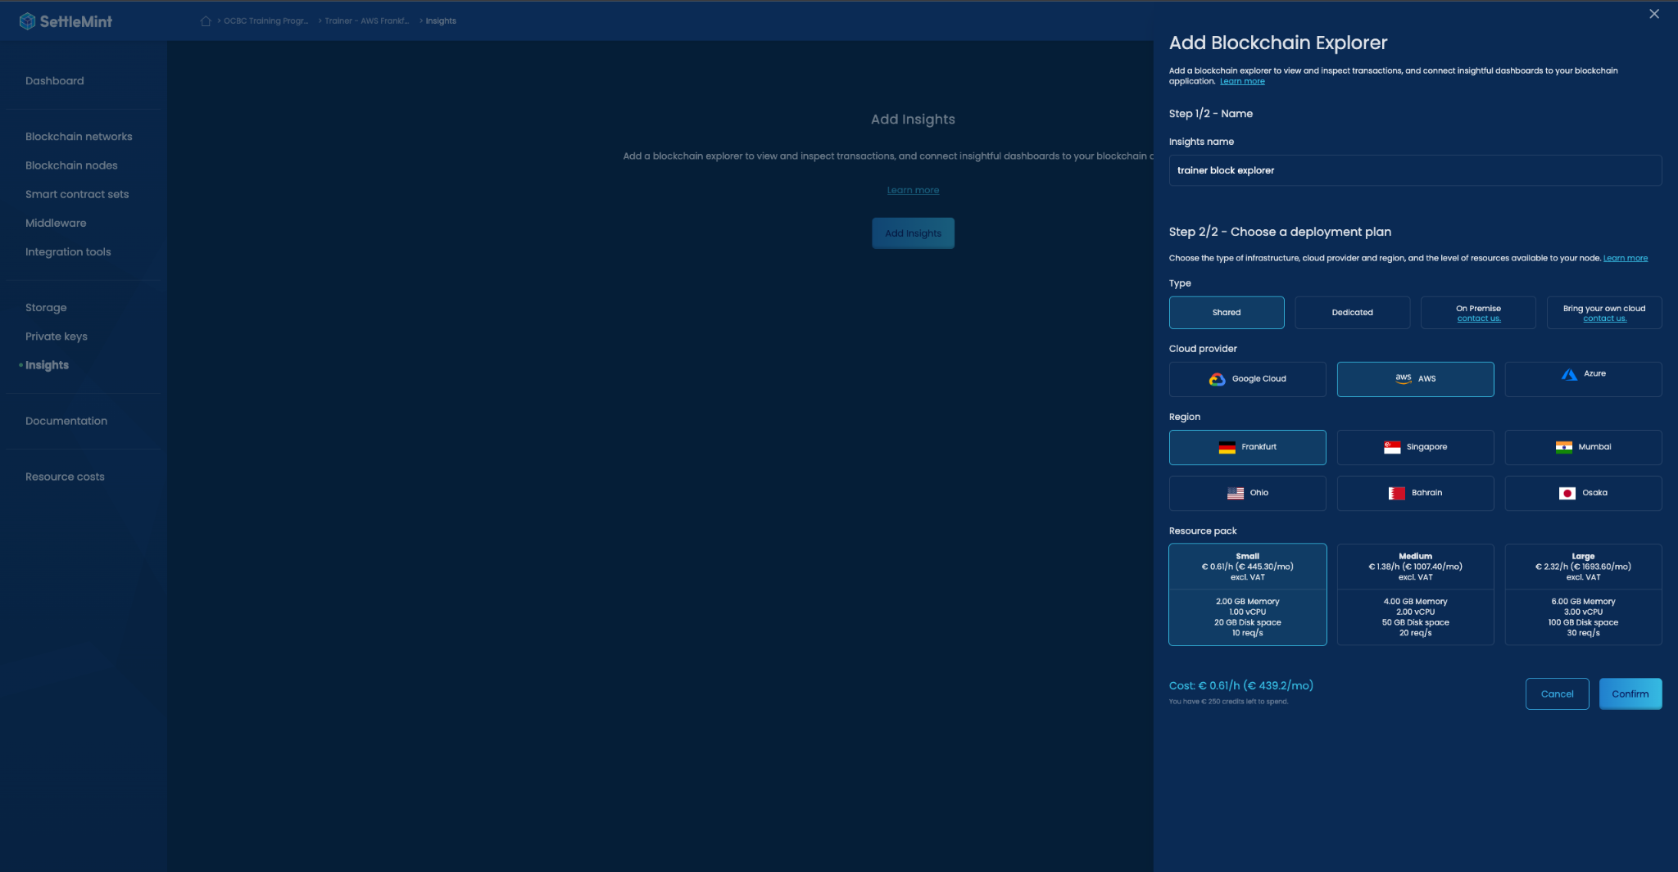  
  
  
Once the Blockscout status changes to "Running," you can proceed to the final step, which is deploying a private key.

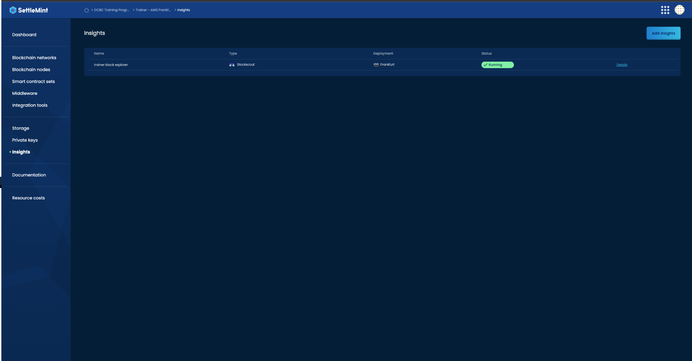

1. DeployTo deploy a private key, please follow these steps:

A. Navigate to the "Private Keys" section in the left menu.

B. Click on the "Add a Private Key" button.

C. Choose the "Accessible" option and select the Besu node that you have deployed.

By following these steps, you will successfully deploy a private key associated with the Besu node you have deployed

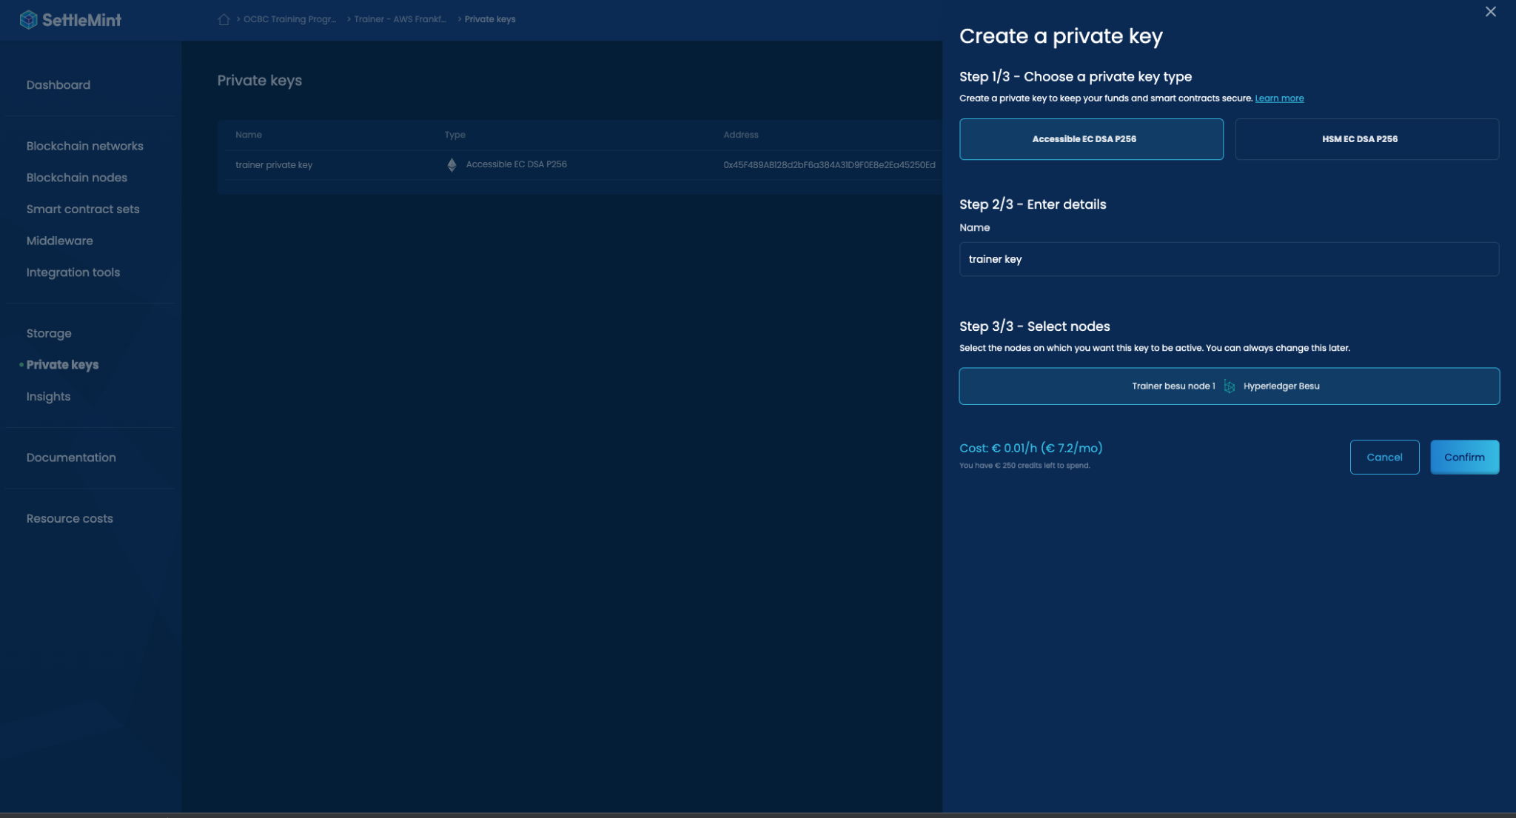

That's it! You are now ready to embark on your blockchain journey!

Course 2 - Part 1

### Deploying Chain On Settlemint : Slide 20

Objective: Gain a full, rapid understanding of the platform by deploying a block and performing a simple task.

1. Create an application within your organization.
2. If you are going to deploy your own node -Follow the instructions provided in the quick start guide.
3. Add a blockchain network to your application.
4. Invite a participant to join your network.

For detailed instructions, refer to:

<https://console.settlemint.com/documentation/docs/using-platform/add-a-network-to-an-application/>

Congratulations! You have successfully launched your first blockchain network. Now, let's interact with the network.

5 - Generate a private key and connect it to your node.

6 - Create an empty set of smart contracts.

7 - Create a file named “HelloWorld.sol” in the contracts folder.

8 - Copy the content of HelloWorld.sol from this {github link} and paste it into the HelloWorld file you created in the previous step.

9 - Remove the 00_deploy_example from the deploy folder and replace it with 00_deploy_HelloWorld.ts. Next, copy and paste the content of 00_deploy_HelloWorld.ts from Github into the file on your platform.

10 - Run the command “pnpm hardhat compile” in the terminal.

11 - Run the command “pnpm hardhat deploy” in the terminal. After this, copy the smart contract address that appears in the terminal and store it somewhere easily accessible.

Congratulations! You have successfully deployed a smart contract. The next step involves interacting with it.

12 - Open Node-RED and paste in the JSON file from Github.

13 - Double click the “greetings connect” node and fill in the requested information.

* Retrieve your private key from the Settlemint platform by navigating to Private Keys and copying the key.
* Enter the smart contract address from the console after deployment.
* For the RPC URL and API key, generate an API key (top right => API Key), then go to Blockchain Nodes => Connect and copy the JSON RPC URL.

The input should look like this: JSON RPC URL / API key.

14 - To modify the variable, click the 'Set Greetings' button, change the “name” to your name, then press the function button."

Done!

### Deploying a NFT - ERC 721 : Slide 57- 59

ERC721 is a standard for unique (Non fungible) tokens on Ethereum.

Token URI is a metadata endpoint that provides information about each token, like name, description, and image. It enables applications to access and display token details, enhancing their value and functionality in the blockchain ecosystem.

Essentially “Minting” an NFT means mapping token ID to your address. Each token ID is usually associated with one token URI.

**Smart contract sets:**

In the Settlemint IDE there are smart contract sets that can help you easily deploy a variety of smart contracts.

One of this sets is the “ERC 721” contract set. While in this task we will not use the Settlemint set it’s recommended to watch the following video before start this task or to watch your instructor walk through.   
  
[Develop & Deploy Smart Contracts Easily | Settlemint Platform Features](https://www.youtube.com/watch?v=yQGeT1TbP5o)

**Pre requests:**

* Settlemint IDE connected
* Integration studio with the “Contract interface” flow.

**Task:**

1. The smart contract :   
   1. Create a new file in your Settlemint IDE inside the contracts folder, let's call “MyNFT.sol”
   2. Get the open zeppelin erc 721 (google erc 721 open zeppelin) or <https://docs.openzeppelin.com/contracts/4.x/erc721> and paste it in MyNFT.sol

pragma solidity ^0.8.0;

import "@openzeppelin/contracts/token/ERC721/extensions/ERC721URIStorage.sol";

import "@openzeppelin/contracts/utils/Counters.sol";

contract GameItem is ERC721URIStorage {

using Counters for Counters.Counter;

Counters.Counter private _tokenIds;

constructor() ERC721("GameItem", "ITM") {}

function awardItem(address player, string memory tokenURI)

public

returns (uint256)

{

uint256 newItemId = _tokenIds.current();

_mint(player, newItemId);

_setTokenURI(newItemId, tokenURI);

_tokenIds.increment();

return newItemId;

}

}





1. Paste it in Remix IDE
2. Change the name of the contract / NFT
3. In Remix compile the smart contract and then deploy it!
4. For demo purposes navigate to an NFT collection, and get a token URI,
   1. Example : open <https://etherscan.io/address/0xbc4ca0eda7647a8ab7c2061c2e118a18a936f13d#readContract>
   2. Navigate to contract tab, and click “read contract”
   3. Scroll down to the “tokenURI” function, and insert the ID of the token ou would like to receive (example number 1)
   4. Copy the string that this token returns
   5. Into the “award” item, now this NFT that you going ot mint will have this token uri
5. Now call the variable “TokenURI” in remix, you will see that it will return the json that points to the MetaData in IPFS!

{

"name": "Asset Name",

"description": "A description of the asset",

"image": "https://link-to-the-image.png",

"attributes": [

{

"trait_type": "Attribute Name",

"value": "Attribute Value"

},

// More attributes...

]

}

// SPDX-License-Identifier: MIT

pragma solidity ^0.8.0;

import "@openzeppelin/contracts/token/ERC721/ERC721.sol";

contract MyNFT is ERC721 {

uint256 public tokenCounter;

constructor () public ERC721 ("MyNFT", "MNFT"){

tokenCounter = 0;

}

function createCollectible(string memory tokenURI) public returns (uint256) {

uint256 newItemId = tokenCounter;

_safeMint(msg.sender, newItemId);

_setTokenURI(newItemId, tokenURI);

tokenCounter = tokenCounter + 1;

return newItemId;

}

}

B- Deploy on a Test net

For this step nothing changes but the network we are deploying to.

1. Start a test net node using settlemint (we will all deploy to the same node to make things faster)
2. Connect Metamask to the test net node <https://support.metamask.io/hc/en-us/articles/360043227612-How-to-add-a-custom-network-RPC>
3. For this example we are using Polygon Mumbai / Avax test net.
   1. Fund your wallet with faucet tokens, to pay the transaction
      1. <https://faucet.avax.network/>
      2. <https://mumbaifaucet.com/>
4. Connect remix to “Injected web 3 provider”
5. Grab the transaction hash from the console and inspect it
   1. <https://mumbai.polygonscan.com/tx/enter> Txn hash here or go to [https://mumbai.polygonscan.com](https://mumbai.polygonscan.com/tx/enter) and input the txn hash in the search bar
6. Lets verify the contract now!   
   Copy contract address form remix and navigate to the contract page in the block explorer
   1. Ex <https://mumbai.polygonscan.com/address/0x9bcf4afb60ecc0cc0025c458deca78d2ddad4008#code>
   2. Press “verify and publish”
      1. Compiler type “single file”
      2. Compiler version - same one as remix
      3. License type same one as in the one in the top of the contract
      4. In remix right click the contract and press “flatten” this is just to make things easier and deploy all our dependencies in “single file”, copy the new contract into the “Enter the Solidity Contract Code below “ ,

The contract is verified! Now you can call it’s function from block explorer and track it from there

Now lets mint An nft with that contract using the block explorer ,

1. navigate to the contract page and Ex <https://mumbai.polygonscan.com/address/0xF4a617BE8C5DDfe61320e130aB53b8128e121AD4#writeContract>
2. Click “write contract”
3. Select the mint function (in this example awarditem), place the token uri that we toke earlier from the bored apes https://olive-lonely-hoverfly-953.mypinata.cloud/ipfs/QmcvooZ7gR8jgxCKrphbu9KYJsvXzspatUgNsxWBJLAymh/1.json , and your address in the address field , press “write! “ the nft is getting minted now

C - Deploying to a test net requires exactly the same steps!

1. Connect MetaMask to a main net
2. Deploy the contract
3. Verify the contract!

### Deploying a ERC 20 : Slide 110

**Training Program: Solidity Contract Development with OpenZeppelin**

**https://github.com/SaeeDawod/training-program/blob/master/course2-part1/erc20-timeLocking/custom-erc20-task.sol**

**Objective:** The objective of this training program is to familiarize you with the basics of writing, deploying, and interacting with Ethereum contracts using Solidity and the OpenZeppelin library.

**Task:** Your task is to complete an ERC20 token contract with specific additional functionalities. The basic contract structure has been provided, and you need to implement the missing functionalities.

Here is what you need to do:

**P1- Work in Remix**

1. **Mint Tokens:** In the constructor of the contract, you need to mint 10 tokens to the contract itself. Use the _mint() function provided by the ERC20 contract from OpenZeppelin to do this.
2. **Transfer Tokens:** Implement a transferTokens function that allows a user to transfer a specified amount of tokens to another user. Use the _transfer() function provided by the ERC20 contract for this.
3. **Burn Tokens:** Implement a burnFrom function that allows the contract owner to burn a specified amount of tokens from any account. You need to use the _burn() function provided by the ERC20 contract. Note that only the contract owner should be able to execute this function.
4. **Whitelist Addresses:** Implement an addToWhitelist function that allows the contract owner to add addresses to a whitelist. Only the contract owner should be able to execute this function.
5. **Withdraw Tokens:** Implement a withdrawToken function that allows whitelisted addresses to withdraw one token from the contract. Use the _transfer() function provided by the ERC20 contract for this. Only whitelisted addresses should be able to execute this function.

**Deployment:** After implementing these functionalities, deploy your contract locally using a development blockchain like Hardhat or remix. You should test your contract functionalities through interaction using ethers.js.

**P2 - Deploying the contract on settlemint**

Remix is good for demos and prototyping but when it comes to building real world applications it’s not good, therefore it’s always recommended to work with a frame work like hardhat which we will learn more about in later chapters.

In P2, we will deploy the erc 20 via the Settlemint platform

1. **Prequests**: Make sure that you have a network up and running, and that your private key is connected to it.
2. **Importing the contract:** import the contract to the contracts folder in the IDE/ smart contract sets.
3. **Deployment script :** write a deployment script
4. **Deploy the token! Smartcontract:deploy or** npx hardhat deploy --network {network name} --tags {tag name}
5. **Adjust the hardhat.config file, add the scanner api key (if public network) etherscan: {  
    apiKey: 'WRCWI9ERS5K6ZEQRKTWEFKNMVPE1BKAMQX', },**
6. **Run npx hardhat verify --network <network> <contract-address> <constructor-arguments>**

**And now the contract is verified in the public block explorer!**

npx hardhat deploy --network {network name} --tags {tag name}

**Note:** Use the OpenZeppelin library for this task. It provides secure and community-audited implementations for ERC20 functionality which you can extend for your contract.

This exercise will help you understand the basic operations of an ERC20 token and how you can extend it with custom functionalities. It will also give you hands-on experience with contract deployment and interaction.

Good luck!

### BlockExplorers : Slide 115

Step 1: find your contract .  
Step2 :

### TikTacToe : Slide 118

After that we have interacted with the blockchain using metamask, we are now going to explore other ways to allow our user to interact with our Dapps in a more seamless manner.

1 - Deploying the contract. We are not expert in this, using the steps from the last session, deploy the following contract <https://github.com/SaeeDawod/training-program/blob/master/tikTacToe/TikTacToe.sol>

3 - open integration studio and create an Api that serves the following script <https://github.com/SaeeDawod/training-program/blob/master/tikTacToe/index.html>

A- Fill in your own contract address

B - Fill in your own private key

C- Fill in your blockchain RPC-URL end point / Api key

C - send the contract to another participant! Who wins?

Questions- answer in the group chat, once you finished 1 round against another player

1. What are the events of the contracts called and how are we listening to them?
2. How is the contract managing the turns?
3. How is the front end connecting to Ethers.js , can you connect your settlemints integration studio to ethers without the cdn?
4. Can you describe how we connected to the smart contract, and how did we call it’s functions and how did we read it’s variables?

### Bank contract : Slide 119

**Training Task: Simple Bank System**

**A -**

**Learning Goals:**

* Understand how to define and use Solidity variables, functions, mappings, and modifiers.
* Get familiar with basic contract design in Solidity.
* Learn to manage Ethereum transactions with Solidity.

**Task Description:**

Create a simple Bank contract with the following features:

1. Account creation: A user can create a bank account with their Ethereum address.
2. Deposit: A user can deposit Ether into their account.
3. Withdraw: A user can withdraw Ether from their account, but cannot withdraw more than their balance.
4. Balance check: A user can check the balance of their account.

**Task Steps:**

1. Define an Account struct that contains an id, owner, and balance.
2. Create a mapping that associates an Ethereum address with an Account.
3. Create a modifier onlyAccountOwner that allows only the owner of an account to execute certain functions.
4. Implement a function createAccount that allows a user to create an account.
5. Implement a function deposit that allows a user to deposit Ether into their account.
6. Implement a function withdraw that allows a user to withdraw Ether from their account.
7. Implement a function getBalance that allows a user to check the balance of their

//Code github step A

**Hints:**

1. createAccount should initialize an Account and add it to the accounts mapping.
2. deposit should update the balance of the sender's Account and should be payable to accept Ether.
3. withdraw should decrease the balance of the sender's

**B -**

**Training Task: Bank System with Loan Management**

**Step B - Loan Management**

**Learning Goals:**

* **Further understand how to use Solidity structs and mappings.**
* **Learn to manage complex functions and operations within a contract.**
* **Learn how to handle more complex conditions and transactions.**

**Task Description:**

**After implementing the features of the bank system in Step A, extend the contract with the following loan management features:**

1. **Loan Creation: A user can create a loan associated with their account.**
2. **Loan Repayment: A user can repay the loan.**
3. **Outstanding Loan Balance Check: A user can check their outstanding loan balance.**

**Task Steps:**

1. **Define a Loan struct that contains an id, accountId, amount, and outstandingBalance.**
2. **Create a mapping that associates a loan id with a Loan.**
3. **Implement a function createLoan that allows a user to create a loan associated with their account. For simplicity, the initial loan amount is the outstanding balance.**
4. **Implement a function repayLoan that allows a user to repay their loan. The repaid amount should be subtracted from their account balance and the loan's outstanding balance.**
5. **Implement a function getOutstandingBalance that allows a user to check the outstanding balance of their loan**

**//github step B**

**Hints:**

1. **createLoan should initialize a Loan and add it to the loans mapping. Remember to ensure the account balance is sufficient for the loan amount.**
2. **repayLoan should decrease the balance of the sender's Account and the loan's outstanding balance by the repayment amount.**
3. **getOutstandingBalance should return the outstanding balance of the specified loan.**

Course 2 - Part 2

### hardhat : Slide 15

In the previous section we used hardhat to deploy contracts. Without diving in depth into the details .

In this section we will learn everything about hard hat

**Step 1: Deploying a contract - Debugging The first issue**

**1 . Create a new file HardHatDemo.sol in the smart contract folder and input to it the following contract**

**contract HardHatDemo {**

**uint256 public counter;**

**constructor(uint256 initialCounterValue) {**

**counter = initialCounterValue;**

**}**

**function add() public {**

**counter++;**

**}**

**function decrease() public {**

**counter--;**

**}**

**}**

****

**Hint: what does the error say?**

**Step 2: Deploying with Hardhat Deploy Syntax**

If working locally First, make sure you have installed the hardhat-deploy plugin by running npm install hardhat-deploy.

Then, create a new deployment script in the deploy folder with the following content:

Build a deployment script :

1. In the deployment folder add a new file name it 00_deploy_counter.ts
2. Take the deployment script from /github link to 01_hardhat_demo.ts , and populate it with the correct values

// deploy/01_deploy_hardhat_demo.ts

const { deploy } = require("hardhat-deploy");

module.exports = async ({ getNamedAccounts, deployments }) => {

// Get the deployer account from the named accounts

const { deployer } = await getNamedAccounts();

// Destructure the deploy function from the deployments object

const { deploy } = deployments;

// Deploy the HardHatDemo contract

await deploy("contract name", {

from: deployer, // Specify the deployer's address

args: [], // Specify the initial counter value here

log: true, // Log deployment details to the console

});

};

module.exports.tags = ["deployment tag"];



Explanation of the script:

1. The script imports the deploy function from the hardhat-deploy package.
2. The module.exports line defines the script as the default export of the module.
3. The script is an async function that accepts an object with two properties: getNamedAccounts and deployments. These properties are provided by the Hardhat deployment process.
4. const { deployer } = await getNamedAccounts(); extracts the deployer property from the object returned by the getNamedAccounts function. This represents the address of the deployer account.
5. const { deploy } = deployments; extracts the deploy function from the deployments object. This function is used to deploy contracts.
6. await deploy("HardHatDemo", { ... }); deploys the "HardHatDemo" contract using the deploy function.
   * from: deployer specifies the address of the deployer account.
   * args: [10] specifies an array of arguments to be passed to the contract's constructor. In this case, it provides the initial counter value of 10.
   * log: true enables logging of deployment details to the console.
7. module.exports.tags = ["HardHatDemo"]; sets the tags property of the module's exports to ["HardHatDemo"]. This associates the "HardHatDemo" tag with the deployment script.

The script deploys the "HardHatDemo" contract with the specified initial counter value using the deploy function. The script is executed during the Hardhat deployment process.

To use this script:

1. Place the script in the deploy folder of your Hardhat project.
2. Modify the args field to specify the desired initial counter value.
3. Run one of the deployment using , option a will attempt to deploy all the contracts in the deploy folder, while option be will only deploy the specified tag
   1. the command npx hardhat deploy --network <network-name>, where <network-name> is the desired network specified in your Hardhat configuration file (hardhat.config.js).
   2. npx hardhat deploy --network {network name} --tags {tag name

**Step 3: Deploying from the Scripts Folder**

Create a new script in the Scripts folder call it lets call it deployHardHatScript.ts

To run the deployment, execute the command npx hardhat run scripts/01_deploy_hardhat_demo.js --network <network-name>, where <network-name> is the desired network specified in your Hardhat configuration file (hardhat.config.js).

const { ethers } = require("hardhat");

async function main() {

const [deployer] = await ethers.getSigners();

const HardHatDemo = await ethers.getContractFactory("contract name");

const contract = await HardHatDemo.connect(deployer).deploy(arg);

console.log(contract);

await contract.decrease();

console.log("New count:", (await contract.counter()).toString());

}

main()

.then(() => process.exit(0))

.catch((error) => {

console.error(error);

process.exit(1);

});



**Step 4: Tasks to Increment and Decrement the Counter**

Create two tasks, increment and decrement, in the scripts folder,

For the increment task (scripts/increment-counter.js):

Use the following syntax and adjust it accordingly

task("say-hello", "Prints a greeting to the console")

.addOptionalParam("name", "The name of the person to greet")

.setAction(async (taskArgs, hre) => {

if (taskArgs.name) {

console.log(`Hello, ${taskArgs.name}!`);

} else {

console.log("Hello, world!");

}

});



Paste the the following require statements to the hardhat config file   
  
require('./tasks/decrement-counter');

require('./tasks/increment-counter');

To run the tasks, execute the commands:

* npx hardhat run increment-counter.ts --network <network-name>
* npx hardhat run decrement-counter.ts --network <network-name>

Replace <network-name> with the desired network specified in your Hardhat configuration file (hardhat.config.js).

**Step 5: Writing and Running a Simple Test**

Create a test file in the test folder, such as hardhatdemo-counter-test.ts, paste in it the script from /training-program/counter-test.ts



import { ethers } from "hardhat";

import { Contract, Signer, ContractFactory } from "ethers";

import { expect } from "chai";

describe("HardHatDemo Contract", function() {

let HardHatDemoContractFactory: ContractFactory;

let hardHatDemoContractInstance: Contract;

let owner: Signer;

beforeEach(async function() {

[owner] = await ethers.getSigners();

HardHatDemoContractFactory = await ethers.getContractFactory("HardHatDemo");

hardHatDemoContractInstance = await HardHatDemoContractFactory.deploy(0);

await hardHatDemoContractInstance.deployed();

});

it("Should initialize counter correctly", async function() {

expect((await hardHatDemoContractInstance.counter()).toNumber()).to.equal(0);

});

it("Should increment the counter", async function() {

await hardHatDemoContractInstance.connect(owner).add();

expect((await hardHatDemoContractInstance.counter()).toNumber()).to.equal(1);

});

it("Should decrement the counter", async function() {

await hardHatDemoContractInstance.connect(owner).add();

await hardHatDemoContractInstance.connect(owner).decrease();

expect((await hardHatDemoContractInstance.counter()).toNumber()).to.equal(0);

});

});



To run the test, execute the command : npx hardhat test

**Step 5: Deploying to a test net ,**

**Step 6: Verifying the contract**

**Note : if not installed - Install the Hardhat Etherscan plugin (it’s installed on the settlmeint platform)**

1. **Import hardhat-etherscan**

**import "@nomiclabs/hardhat-etherscan";**

****

1. **Get API keys from the block explorer** [**https://docs.polygonscan.com/getting-started/viewing-api-usage-statistics**](https://docs.polygonscan.com/getting-started/viewing-api-usage-statistics)
2. **Place the keys inside the Conifg object in the hardhat.ts file**

**const config: HardhatUserConfig = {**

**// other configurations...**

**etherscan: {**

**apiKey: "Your Etherscan API key",**

**},**

**};**

1. **Run in your terminal the command**

**npx hardhat verify --network NETWORK_NAME DEPLOYED_CONTRACT_ADDRESS "Constructor argument 1"**

****

**Congratulations you have verified your contract!**

**Step 7: Changing network**

**In you can easily switch the network for which you are deplpoying your contract to using the same hardhat.config file.**

**All you have to do is to add the network inside the hardhat config object, and deploying the contract to that network using your preferred deployment method.**

**const config: HardhatUserConfig = {**

**// other configurations...**

**networks: {**

**ether-network-name: “RPC url”,**

**},**

**};**

****

### Car rental : Slide 21 - debugging Car rental contract:

**Task: Debugging a Car Rental Contract**

**Introduction**

You are given a Solidity contract for a car rental service. The contract has several bugs and it's your job to find and fix them. The contract allows for the following:

* A contract owner (the car rental service) can add cars to the inventory.
* Users can view available cars, rent a car by paying a deposit, and specifying a rental period.
* Users can return the car and the contract calculates any penalties based on the delay in returning the car.
* The contract owner can withdraw the payments collected.

However, the contract is not working as expected due to several bugs. Your task is to identify these bugs and fix them.

**Contract Code**

Here is the buggy contract code:

GitHub link

**Instructions**

1. Read and understand the contract code.
2. Identify the bugs in the contract. There are subtle issues with types of variables, visibility of functions, and more.
3. Fix the bugs and ensure the contract works as expected.

**Hints**

1. Check the types of all variables. Are they appropriate for their intended use? //BUG 1
2. Look at the visibility modifiers for the functions. Are they correct? //BUG 4
3. Pay attention to the calculation of the penalty in the returnCar function. //BUG 6
4. Look carefully at the rentCar function. //BUG 2, BUG 3
5. Don't forget to check the modifiers used in the functions.

### Capture the flag : Slide 40 - Ethernaut

1. <https://ethernaut.openzeppelin.com/level/0x2a24869323C0B13Dff24E196Ba072dC790D52479>

**Objective**: The goal of this challenge is to gain control over the contract and then drain its balance.

**Prerequisites**:

Set up an environment where you could easily interact with smart contracts ( for quick start you could use remix ide/ integration studio)

* Familiarity with Ethereum's ABI for interacting with contracts
* Understanding of how to send ether to contracts
* Knowledge of unit conversions in Ethereum (wei/ether)
* Understanding of fallback methods in Solidity

**Hints and Guidelines**

1. **Understanding the Contract**: The contract has two key functions that can change the owner of the contract: contribute() and the fallback receive(). Understanding how these functions work is crucial to solving the challenge.
2. **Making a Contribution**: The contribute() function allows a user to increase their contribution to the contract. However, there's a limit to how much you can contribute in a single transaction. Think about how you can work around this.
3. **Using the Fallback**: The receive() function is a fallback function that gets called when the contract receives Ether without a function call. This function also has the ability to change the contract's owner. Consider how you can use this to your advantage.
4. **Draining the Contract**: Once you have ownership, you can drain the contract's balance. The contract provides a function for this, but you'll need to be the owner to use it.

**Solution**

**Step 1: Gaining Ownership**

* First, call the contribute() function with a small amount of ETH. This is necessary because the receive() function will revert without a prior contribution. Use the following command:

await contract.contribute({value: 10})



Next, send ETH directly to the contract's address. This will trigger the receive() function. You can get the contract address with the following command:

await contract.address



* Finally, verify that you have become the owner:

await contract.owner()



**Step 2: Draining the Contract**

Once you have ownership, you can drain the contract's balance by calling the withdraw() function. Use the following command:

await contract.withdraw()



**Conclusion**

This challenge illustrates the importance of carefully managing critical functions in smart contracts. Public and external functions are accessible to anyone on the blockchain, so they should not contain sensitive logic such as ownership transfers.

1. <https://ethernaut.openzeppelin.com/level/0xD2e5e0102E55a5234379DD796b8c641cd5996Efd>

**Objective**: The goal of this challenge is to claim ownership of the contract.

**Prerequisites**:

* Familiarity with Solidity and Ethereum smart contracts
* Understanding of contract constructors and their role in Solidity
* Knowledge of Solidity versions and their differences

**Hints and Guidelines**

1. **Examine the Contract**: The contract's name is "Fallout", but there's a function named "Fal1out". This could be a typo or a deliberate mistake. Investigate how this could be exploited.
2. **Understand Constructors**: In Solidity, constructors are special functions that are executed upon contract creation. They are typically used to initialize state variables. However, in Solidity versions prior to 0.4.22, constructors were defined as functions with the same name as the contract. This has changed in later versions to avoid mistakes, but this contract seems to be using the old convention.
3. **Spot the Mistake**: The contract's constructor seems to be misspelled. This means it's not being called when the contract is created, leaving the contract in an uninitialized state. This could be the key to claiming ownership.

**Solution**

**Step 1: Claiming Ownership**

The solution to this challenge is straightforward. You just need to call the "Fal1out" function, which was intended to be the constructor. Because of the typo, it's now a regular function that can be called by anyone. When called, it sets the contract's owner to the caller. Use the following command:

await contract.Fal1out()



Verify that you have become the owner:

await contract.owner()



**Conclusion**

This challenge demonstrates the importance of careful coding and understanding the nuances of the programming language you're using. A simple typo can lead to serious security vulnerabilities. Always make sure to use the latest version of Solidity and follow the best practices for smart contract development.

1. <https://ethernaut.openzeppelin.com/level/0xbF361Efe3FcEc9c0139dEdAEDe1a76539b288935>

**Objective: The goal of this challenge is to win the coin flip 10 times in a row.**

**Prerequisites:**

* Familiarity with Solidity and Ethereum smart contracts
* Understanding of how Ethereum blocks and block numbers work
* Knowledge of how to interact with a deployed contract at an address

**Hints and Guidelines**

1. **Examine the Contract**: The contract simulates a coin flip game where you need to guess the outcome of a coin flip. The contract uses the block number of the Ethereum network to simulate randomness. However, this is not truly random, and you can exploit this.
2. **Understand the Coin Flip Mechanism**: The contract uses the block number of the Ethereum network to generate a pseudo-random number. This number is then used to determine the outcome of the coin flip. However, the block number can be easily accessed, and you can use this information to predict the outcome of the coin flip.
3. **Spot the Vulnerability**: The contract's randomness is not truly random. You can predict the outcome of the coin flip by accessing the block number of the Ethereum network. This is the key to winning the coin flip 10 times in a row.

**Solution**

**Step 1: Create a Contract to Predict the Coin Flip**

* You can create a contract that uses the same mechanism as the CoinFlip contract to predict the outcome of the coin flip. This contract should have a function that takes the address of the CoinFlip contract as a parameter and uses the block number to predict the outcome of the coin flip.



pragma solidity ^0.6.0;

interface ICoinFlip {

function flip(bool _guess) external returns (bool);

}

contract CoinFlipGuess {

uint256 public consecutiveWins = 0;

uint256 lastHash;

uint256 FACTOR = 57896044618658097711785492504343953926634992332820282019728792003956564819968;

function coinFlipGuess(address _coinFlipAddr) external returns (uint256) {

uint256 blockValue = uint256(blockhash(block.number - 1));

if (lastHash == blockValue) {

revert();

}

lastHash = blockValue;

uint256 coinFlip = blockValue / FACTOR;

bool side = coinFlip == 1 ? true : false;

bool isRight = ICoinFlip(_coinFlipAddr).flip(side);

if (isRight) {

consecutiveWins++;

} else {

consecutiveWins = 0;

}

return consecutiveWins;

}

}



**Step 2: Deploy the Contract and Call the Function**

* Deploy the CoinFlipGuess contract and call the coinFlipGuess function with the address of the CoinFlip contract as a parameter. Do this 10 times to win the coin flip 10 times in a row.

**Conclusion**

**This challenge demonstrates the importance of understanding the underlying mechanisms of smart contracts and the Ethereum network. It also highlights the pitfalls of using pseudo-randomness in smart contracts.**

1. <https://ethernaut.openzeppelin.com/level/0x36E92B2751F260D6a4749d7CA58247E7f8198284>

**Challenge: Dex**

**Objective:** The goal of this level is for you to hack the basic DEX contract and steal the funds by price manipulation. You will start with 10 tokens of token1 and 10 of token2. The DEX contract starts with 100 of each token. You will be successful in this level if you manage to drain all of at least 1 of the 2 tokens from the contract, and allow the contract to report a "bad" price of the assets.

**Hints:**

1. Understand how the price of the token is calculated.
2. Understand how the swap method works.
3. Understand how to approve a transaction of an ERC20.
4. There's more than one way to interact with a contract!
5. Using Remix might help.
6. Understand what "At Address" does.

**Solution:**

1. The first step is to approve the Dex contract to manage all of your tokens. This can be done by calling the approve function on both token1 and token2 with the address of the Dex contract and the maximum possible amount.

token1.approve(address(level), 2**256 - 1);

token2.approve(address(level), 2**256 - 1);



2. The next step is to continuously swap tokens back and forth to manipulate the price. This can be done by calling the swap function on the Dex contract multiple times. The goal is to make the balance of the token being sold (tokenIn) much lower compared to the balance of the token being bought (tokenOut).

swapMax(token1, token2);

swapMax(token2, token1);

swapMax(token1, token2);

swapMax(token2, token1);

swapMax(token1, token2);



3, After all these swaps, the balance of the tokens will be manipulated in such a way that the Dex contract will not have enough balance to execute the transfer. Therefore, you need to calculate the amount of token2 to sell in order to get back 110 token1.

level.swap(address(token2), address(token1), 45);

1. Finally, you can check if you have successfully drained all of at least one of the tokens from the Dex contract.

Conclusion

**Note:** This solution exploits the fact that the Dex contract uses the balance of the tokens to calculate the swap price, which can be manipulated by continuously swapping tokens back and forth. It also exploits the fact that Solidity does not support floating point numbers, causing the contract to lose precision and eventually drain all of one of the tokens.

Ninja challenges:

1. <https://ethernaut.openzeppelin.com/level/0x0AFc648f6D22390d6642Ebc7e1579fC480FE2278>
2. <https://ethernaut.openzeppelin.com/level/0x2a2497aE349bCA901Fea458370Bd7dDa594D1D69>
3. https://ethernaut.openzeppelin.com/level/0xf59112032D54862E199626F55cFad4F8a3b0Fce9

### Gas optimisation - Slide 59

Let's go through this link together for detailed :

<https://github.com/devanshbatham/Solidity-Gas-Optimization-Tips>

### MultiSig - Slide 65

**Task: Creating a Simple Multisig Wallet in Solidity**

Objective: Write a simple multisig wallet contract in Solidity.

Instructions:

1. Define the contract and set the number of required signatures and the owners of the wallet.
2. Create a struct for transactions that includes the destination address, the value of the transaction, and a boolean to indicate whether the transaction has been executed.
3. Implement a function to submit a transaction. This function should add the transaction to a pending transactions array and emit an event.
4. Implement a function for owners to confirm transactions. This function should check that the sender is an owner and that they have not already confirmed the transaction.
5. Implement a function to execute a transaction once the required number of confirmations has been reached. This function should send the specified value to the destination address and mark the transaction as executed.
6. Add additional owners
7. Test your contract with different participants and scenarios to ensure it works as expected.

-example solution can be found in github

### Proxy - Slide 71

**Task: Creating and Upgrading a Simple UUPS Contract using Hardhat**

Objective: Write a simple storage contract in Solidity, deploy it using Hardhat, and then upgrade it using a UUPS proxy contract.

Instructions:

1. **~~Setup your environment~~**~~: Install Node.js and npm. Initialize a new Hardhat project by running npx hardhat in your terminal and selecting "Create an empty hardhat.config.js" when prompted.~~
2. **~~Install necessary plugins~~**~~: Install the OpenZeppelin Hardhat Upgrades plugin by running npm install --save-dev @openzeppelin/hardhat-upgrades in your terminal.~~
3. **Import the plugin in your Hardhat config**: Add the following line to your hardhat.config.js file:

require('@openzeppelin/hardhat-upgrades');



**4. Write your contracts**: Define a Box contract and a BoxV2 contract in separate Solidity files.

The Box contract should have a state variable to store a single value and a function to retrieve that value. Here's an example:

// SPDX-License-Identifier: MIT

pragma solidity ^0.8.0;

contract Box {

uint private _value;

function setValue(uint newValue) public {

_value = newValue;

}

function getValue() public view returns (uint) {

return _value;

}

}



The BoxV2 contract should be an upgraded version of Box with additional functionality. For example, you could add a function to double the stored value:



// SPDX-License-Identifier: MIT

pragma solidity ^0.8.0;

contract BoxV2 {

uint private _value;

function setValue(uint newValue) public {

_value = newValue;

}

function getValue() public view returns (uint) {

return _value;

}

function doubleValue() public {

_value = _value * 2;

}

}



**5. Deploy the initial contract**: Write a Hardhat script to deploy your Box contract using the deployProxy function from the upgrades plugin. Here's an example:

const { ethers, upgrades } = require("hardhat");

async function main() {

const Box = await ethers.getContractFactory("Box");

const box = await upgrades.deployProxy(Box, [42]);

await box.deployed();

console.log("Box deployed to:", box.address);

}

main()

.then(() => process.exit(0))

.catch(error => {

console.error(error);

process.exit(1);

});



1. **nteract with the contract**: Write a Hardhat script to interact with your Box contract. Call the setValue function to change the value stored in the contract, and then call the getValue function to verify the updated value.
2. **Upgrade the contract**: Write a Hardhat script to upgrade your Box contract to BoxV2 using the upgradeProxy function from the upgrades plugin. Here's an example:



const { ethers, upgrades } = require("hardhat");

async function main() {

const BoxV2 = await ethers.getContractFactory("BoxV2");

const upgradedBox = await upgrades.upgradeProxy(existingProxyAddress, BoxV2);

console.log("Box upgraded to:", upgradedBox.address);

}

main()

.then(() => process.exit(0))

.catch(error => {

console.error(error);

process.exit(1);

});



Course 2 - Part 3

For the following tasks feel free to use any tool at your disposal in the Settlemint platform,

The Merkel proofs are detailed in depth, but as you progress the tasks will be less detailed, and you will have to choose for yourself what approach you are taking to build your Dapps. And research online the topics at hand!

### Merkel Proofs fixed version - zk - Slide x

**Tutorial: Introduction to Merkle Trees, Zero-Knowledge Proofs, and zkRollups**

**Introduction**

In this tutorial, we'll be exploring the concepts of Merkle Trees, Zero-Knowledge Proofs (ZKPs), and zkRollups. We'll then take a hands-on approach by creating a basic application that uses these concepts.

We'll then take a hands-on approach by creating a basic application that uses Merkeltrees to whitelist users and allowing them to mint a “point” without exposing users information to the public.

Only users who know their “secert” will manage to generate a hash which will check we can abstract it form the root hash of the merkel tree.

**Zero-Knowledge Proofs**

Zero-Knowledge Proofs are a cryptographic method by which one party (the prover) can prove to another party (the verifier) that they know a value x, without conveying any information apart from the fact that they know the value x.

**zkRollups**

zkRollups are a Layer-2 scaling solution that use Zero-Knowledge Proofs to bundle multiple off-chain transactions into a single on-chain proof that can be verified by anyone. They offer a solution for Ethereum's scalability issues by allowing more transactions to be processed off-chain while still maintaining on-chain security.

**Merkle Trees**

A Merkle Tree is a binary tree of hashes. It starts with the "leaves" at the bottom -- these are hashes of data blocks. Then each pair of leaves is hashed together to form the next level up in the tree. This process is repeated until we get to the root of the tree, also known as the Merkle Root.

This structure allows us to create a "proof" that a certain piece of data is in the tree, without having to know all the other data in the tree. This proof is just the minimum set of hashes that we need to compute the Merkle Root.

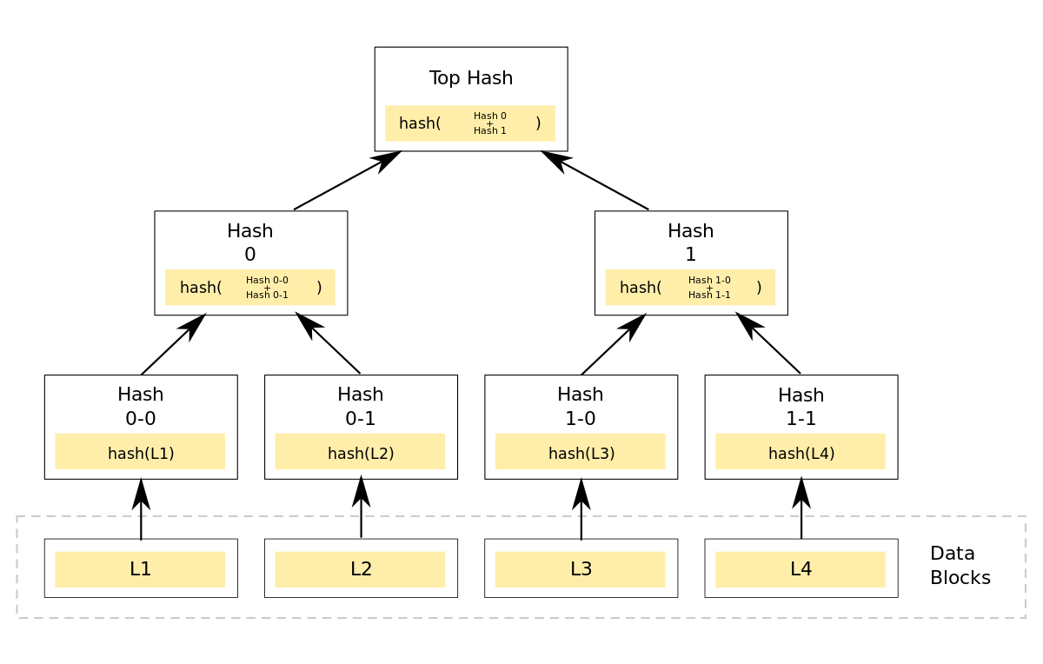

The “top hash” is also known as “the root hash”

Still confused? Take a moment to watch : <https://www.youtube.com/watch?v=fB41w3JcR7U>

Pre requests:

1. Basic knowledge of the settlemint platform
2. Network and a node deployed
3. Basic understanding of Smart contract and how to deploy them
4. ethers.js

Tools:

1 - Integration studio:

2 - Hasura :

Steps:

1. Create users table in Hasura
2. Create a Deterministic way of hashing the data in integration studio
3. Create a smart contract that stores the RootHash and checks the leaves against it
4. Create in integration studio helper functions that produce the proof and leaves that will be checked against the rootHash in the smart contract.

**Step 1: Create users table in Hasura**

1. Inside your application navigate to the integration tools tab, and deploy a new Hasura instance.

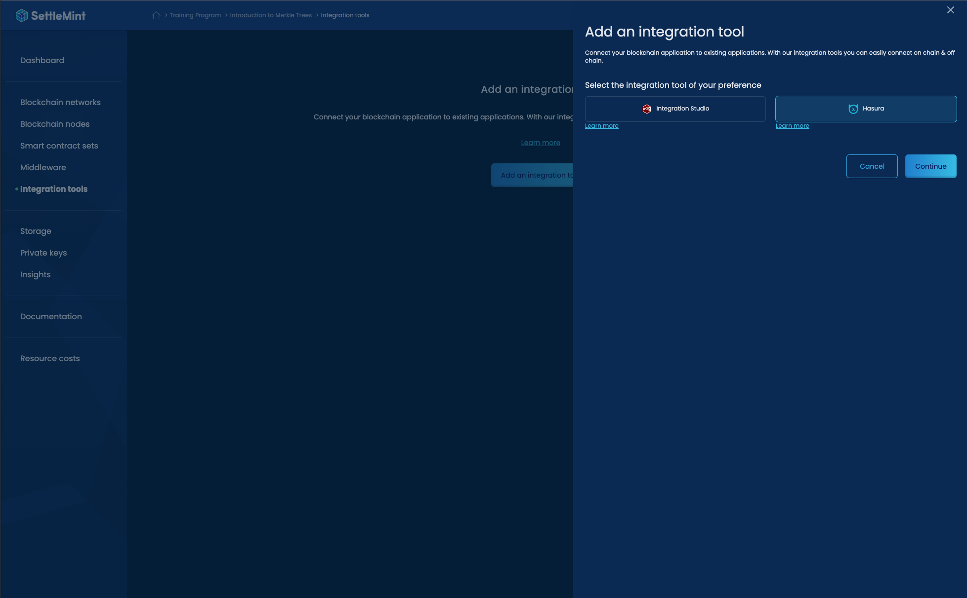

1. Deploy a new Hasura instance by following the Deploying page, for demo purposes we can start by deploying it using the shared plan, with a small resource pack.  
   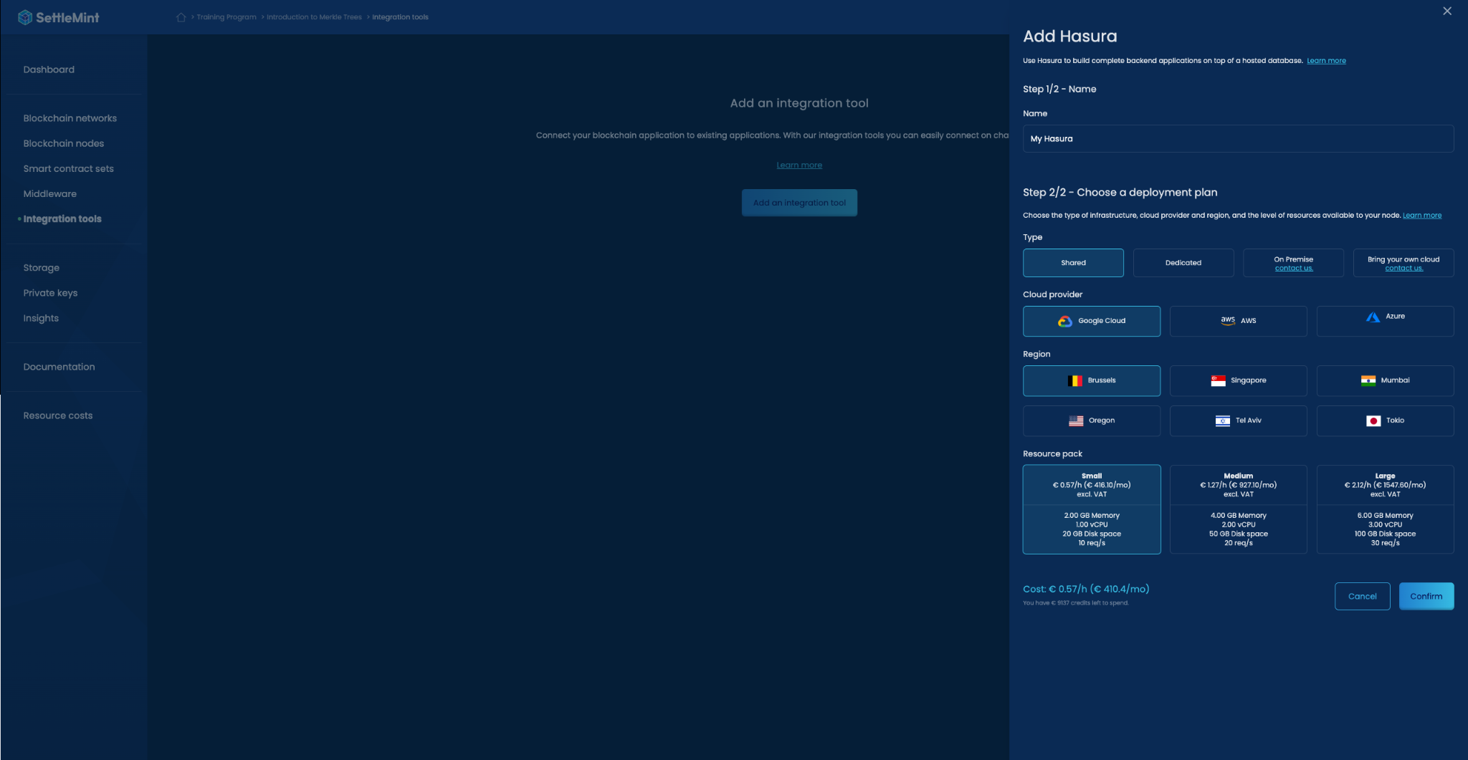
2. Once Hasura is deployed press on the Hasura instance, and navigate to the connection tab, copy the Hasura admin secret

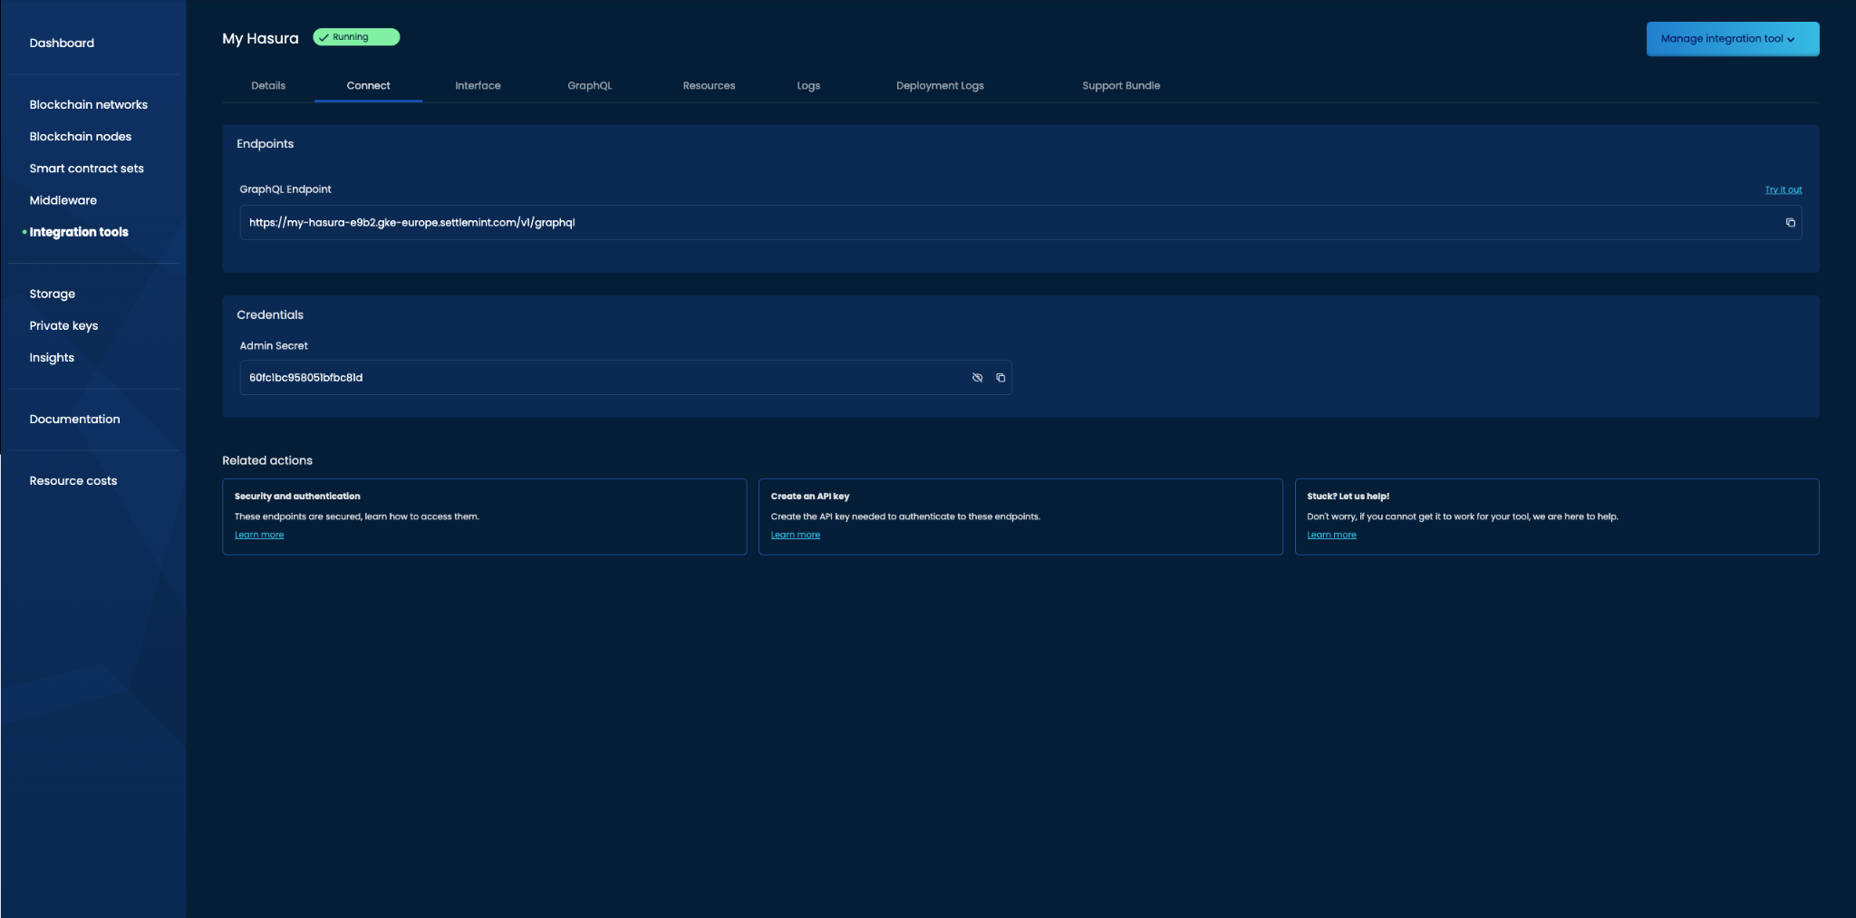

1. Navigate to the interface tab and paste the admin Secret , after inputting the secret you will see your **Hasura Console ! (press view in full mode for a better user experience)**

While Hasura allows you to connect to existing almost any existing SQL database for this example we create a new table to keep it simple using the Hasura Console.

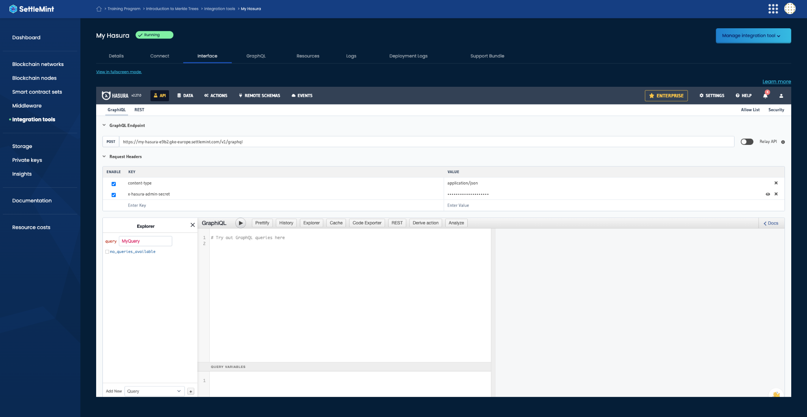

1. Navigate to the Data tab on the top navigation bar. And in the left menu “Data Manager” pick the public folder, once you choose it you will see the following page, press “Create table”

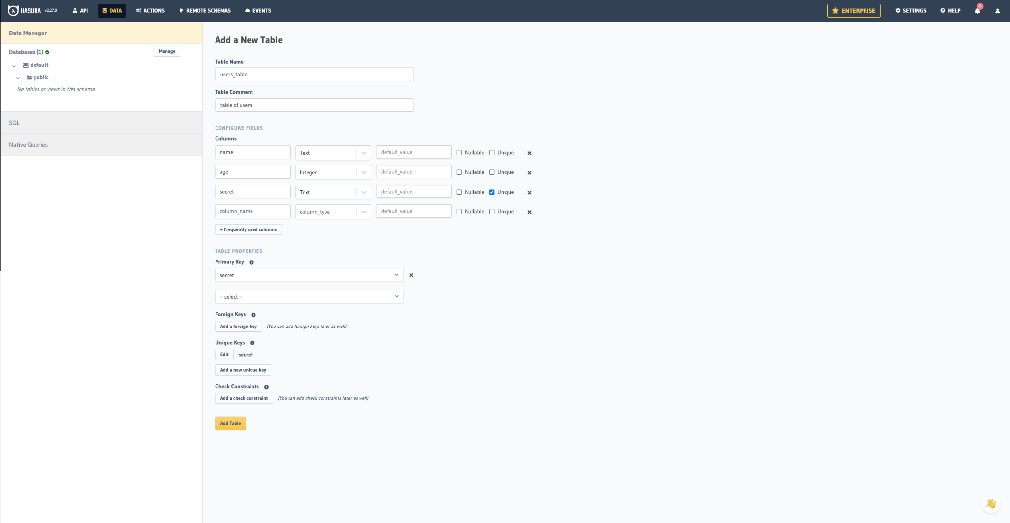

1. Initiate a table with the following configuration, once you are done press “Add table”

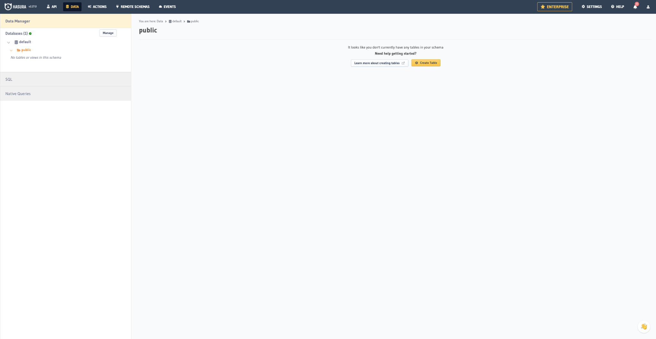

1. Take a moment to navigate the different pages, as you see in the modify tab you can edit the table, in the Browse Rows tab you can see the tables, Permission tab can help you for access control,

When you are ready, visit the “insert raw” tab and add 3 users, make sure that the secret is something that would be easy for you to remember as we will use it later on.

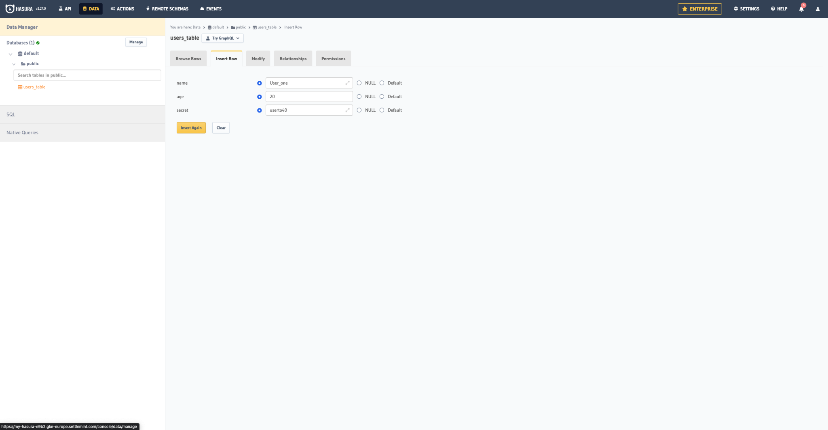

If you visit the “Browse raws” tab you will see the 3 new users that we added.

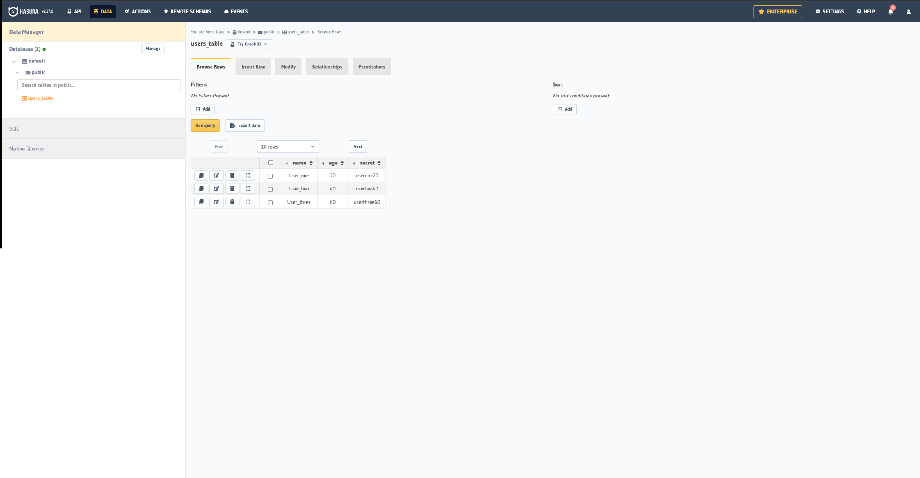

**Our database is now ready!**

**Step 1.5: exporting the queries from hasura**

**Lets now export the queries so we could use them in integration studio in step 2.**

1. lets create a function that fetches the data, and aggregates , and then uses the MerkelJS library to Generate Root hash.  
     
   To import the data from Hasura we will need to create
   1. Api key ( follow this guide)

https://console.settlemint.com/documentation/docs/using-platform/api-keys/

* 1. Get the code from Hasura code generator, you can do so by building the query in the explorer tab in left, and then pressing the “Code exporter button”

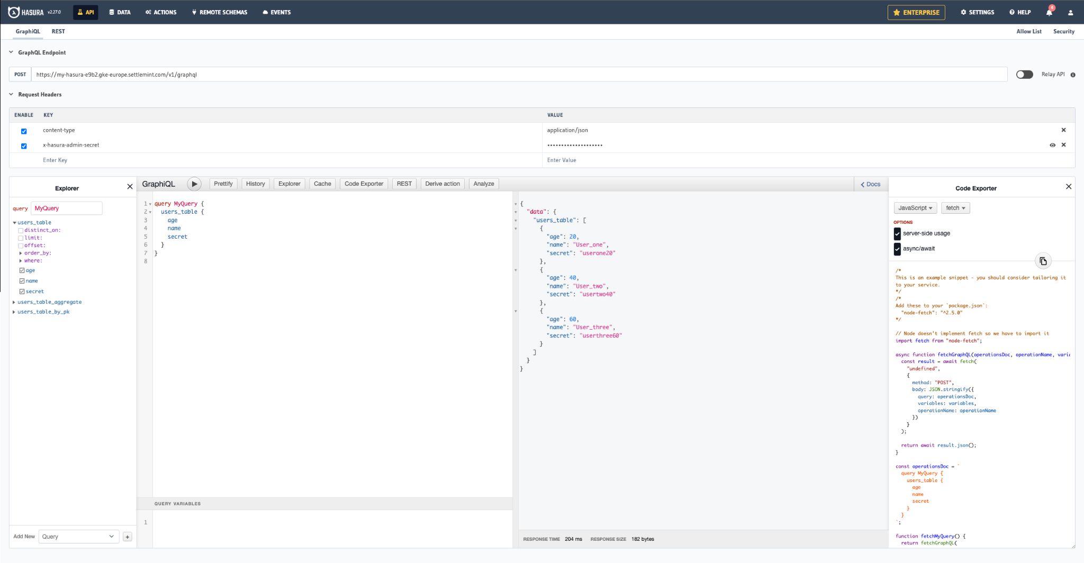

You will have add to the fetchGraphQL function the Headers filed, in order to authenticate the requests

headers: {

"Content-Type": "application/json",

"x-hasura-admin-secret": "Hasursa admin key",

"x-auth-token":"Settlemint Api key"

},

It will look like this inside the fetchGraphQL function , you can in your code replace yours with the following code snippet and input your own information

****

async function fetchGraphQL(operationsDoc, operationName, variables) {

const result = await fetch(

"YOUR HASURA URL",

{

method: "POST",

headers: {

"Content-Type": "application/json",

"x-hasura-admin-secret": "60fc1bc958051bfbc81d",

"x-auth-token":"bpaas-14a6d91387631ccbcc70D90ea5B5fc77795Cdd39"

},

body: JSON.stringify({

query: operationsDoc,

variables: variables,

operationName: operationName

})

}

);

return await result.json();

}

****

**Part 2: Integration studio- admin flow**

a . Deploy an instance of integration studio, in the same way you deployed Hasura.

b **.**create a function node that when triggered (using inject) it returns the root hash.

To do so, navigate to your new integration studio flow, and drag an “inject” node to the dashboard. Double click it and rename it to “Admin: Create Merkel Tree”.

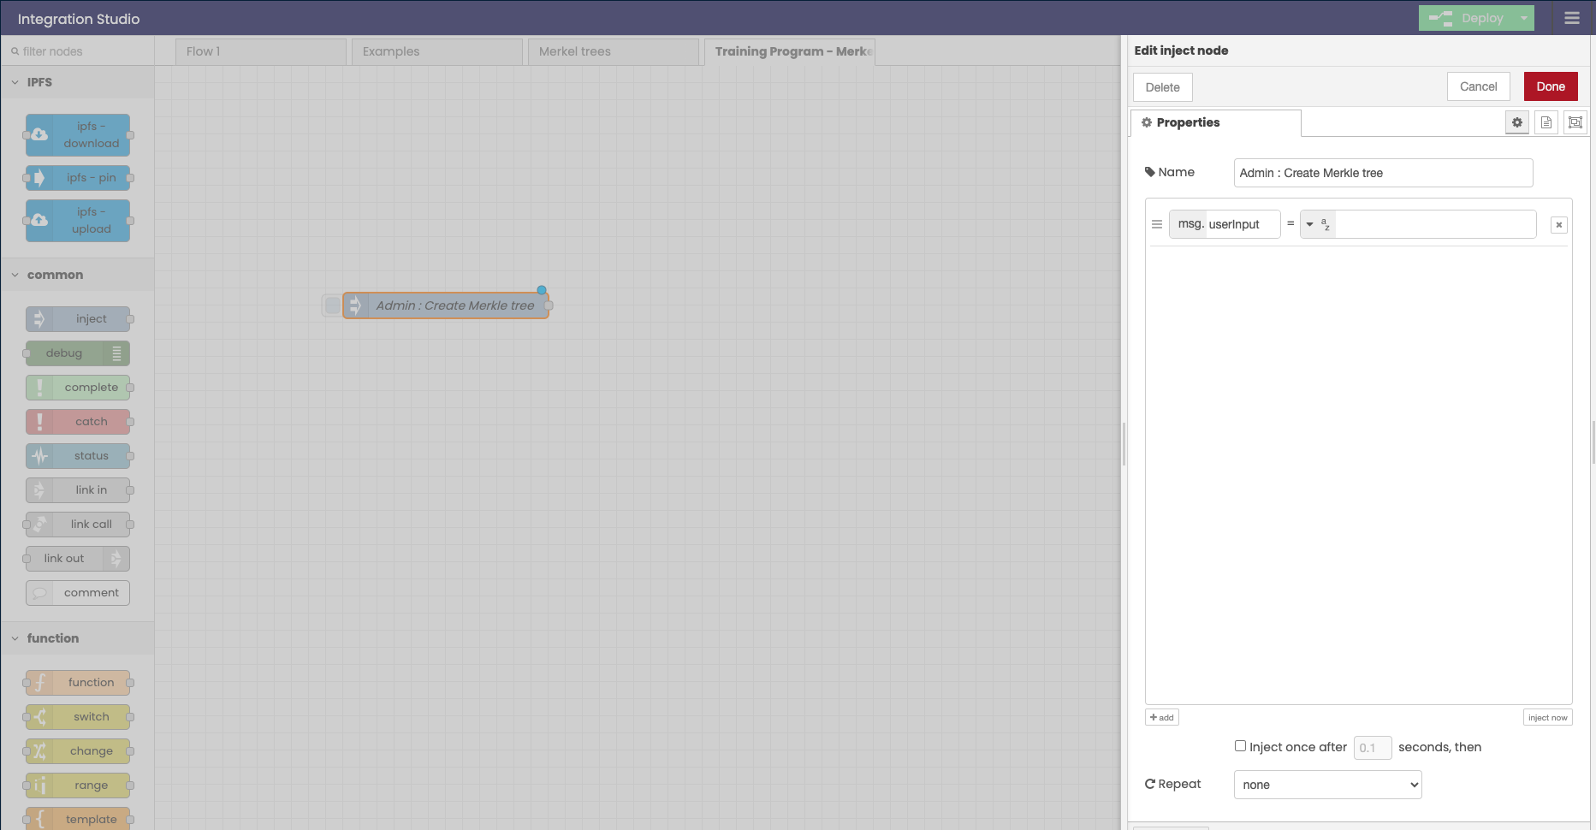

This will be used to trigger the following function node.

2- add a function node to that fetches data form hasura and creates merkel trees.

2.1 explanation :

Next we will add a function node to our integration studio flow, this function node will fetch our Hasura Database using the script that we created and then it will extract each user it’s age. Name, and secret , it will make 1 string out of them, and hash that string.

We will later use the hashed strings that we created to create a root hash which will be hosted on the blockchain.

This way we are able to verify if our user “secert” or any other information about him is correct without exposing their information to the blockchain.

Lets dive deeper into how this is done:

2.1. Before working hands and preparing the script which will run the javascript that we copied in step 1.5 “export queries from hausra”. Its important to understand the process that we are doing. Then we will provide you with the code snippets!

First we will use the code from hasura code exporter , to fetch the information from the database.

We will get an object that looks like this

{

users_table: [

{ age: 20, name: 'User_one', secret: 'userone20' },

{ age: 40, name: 'User_two', secret: 'usertwo40' },

{ age: 60, name: 'User_three', secret: 'userthree60' }

]

}



Our goal now is to create a hash for each user using his information, and we are doing so by extracting the values of each user and combining them together into one string and then hashing it with keccak256.

So after fetching the database we will parse it with the following function, this function simply takes the values of the object and creates 1 keccak hash form them

function organizeAndHashUsers(users) {

const hashes = [];

for (const user of users) {

const { age, name, secret } = user;

const dataToHash = age.toString() + name + secret;

const hash = keccak256(dataToHash).toString('hex');

hashes.push(hash);

}

return hashes

}



To break it down:

So the object

 { age: 20, name: 'User_one', secret: 'userone20' },



Will become

 20User_oneuserone20



Then we will run this string in the keccak256 function (we will be importing this function from the keccak256 - ethers lib)

keccak256(20User_oneuserone20) // this results in something like this 41bb1e44bc70ec73abff22e9968938cf52f18cfc15cd3cc28fa49873ed7d5a79



Then to match the solidity keccak256 we will add the prefix “0x”

So the end result will be a hash looking like 0x41bb1e44bc70ec73abff22e9968938cf52f18cfc15cd3cc28fa49873ed7d5a79



So for each user in the database we will have an keccak256 hash representing him in an array

[

'41bb1e44bc70ec73abff22e9968938cf52f18cfc15cd3cc28fa49873ed7d5a79',

'dce01d42480af923fab205a2e4291d4803291389410a084504b786e4fdcf8b61',

'4007e85b723e582d22cc6061558c51eaf16719a19ddb95a749f33375f6ee0080'

]



And form this array we will derive a roothash using the merkel tree algorithm .

So our end result will be 32bytes hash that we will deploy on the blockchain and use it to check if our user is allowed to run the function “getPoint”

Merkel tree js example:



const addresses = msg.addresses

// // Hash addresses to get the leaves

let leaves = addresses.map(keccak256)

// // Create tree

let merkleTree = new merkletreejs.MerkleTree(leaves, keccak256, { sortPairs: true })

// // Get root

let rootHash = merkleTree.getRoot().toString('hex')

global.set("merkleTree", merkleTree);

global.set("rootHash", '0x' + rootHash);

msg.payload = '0x' + rootHash

return msg



The root hash would look something like this

0x4fcbd8c9f9b5f45d45f2a9fb150a4e696158e621593e45cb4a7877d094dc6a08



Now that explaining the functions and concept is behind us we are ready for the next step.

2.2 create a GetData function node

1- drag a new function node

2- double click it rename it to get Data

3- name the function node and import the following libraries by double clicking the function node  
  
 2. Keccak256  
 3. Node-fetch  
  
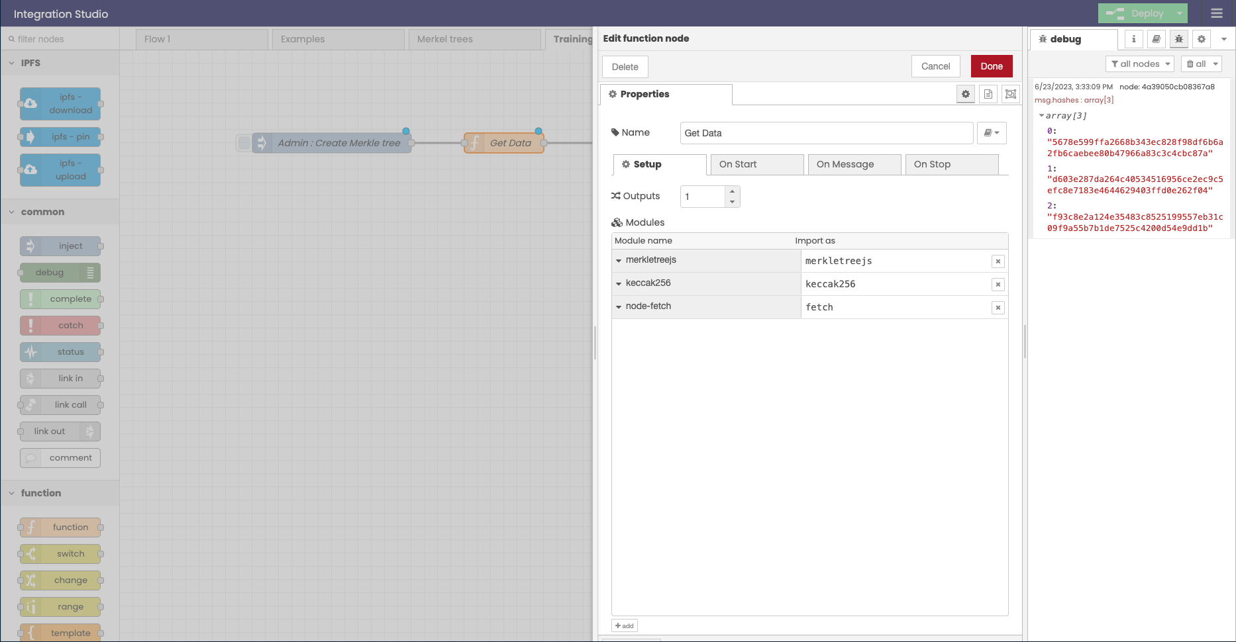

3- import hasuras code exporters script and add to it the organizeAndHashUsers(user)

Which we created earlier

organizeAndHashUsers(user)



The complete code snippet would look like this, make sure that you change the information to match your own.

async function fetchGraphQL(operationsDoc, operationName, variables) {

const result = await fetch(

"https://my-hasura-e9b2.gke-europe.settlemint.com/v1/graphql",

{

method: "POST",

headers: {

"Content-Type": "application/json",

"x-hasura-admin-secret": "my secret",

"x-auth-token": "bpaas-my token"

},

body: JSON.stringify({

query: operationsDoc,

variables: variables,

operationName: operationName

})

}

);

return await result.json();

}

const operationsDoc = `

query MyQuery {

users_table {

age

name

secret

}

}

`;

function fetchMyQuery() {

return fetchGraphQL(

operationsDoc,

"MyQuery",

{}

);

}

async function startFetchMyQuery() {

const { errors, data } = await fetchMyQuery();

if (errors) {

console.error(errors);

}

return organizeAndHashUsers(data.users_table)

}

function organizeAndHashUsers(users) {

const hashes = [];

for (const user of users) {

const { age, name, secret } = user;

const dataToHash = age.toString() + name + secret;

const hash = keccak256(dataToHash).toString('hex');

hashes.push(hash);

}

return hashes

}

msg.hashes = await startFetchMyQuery();

return msg



This is how your integration studio should look like

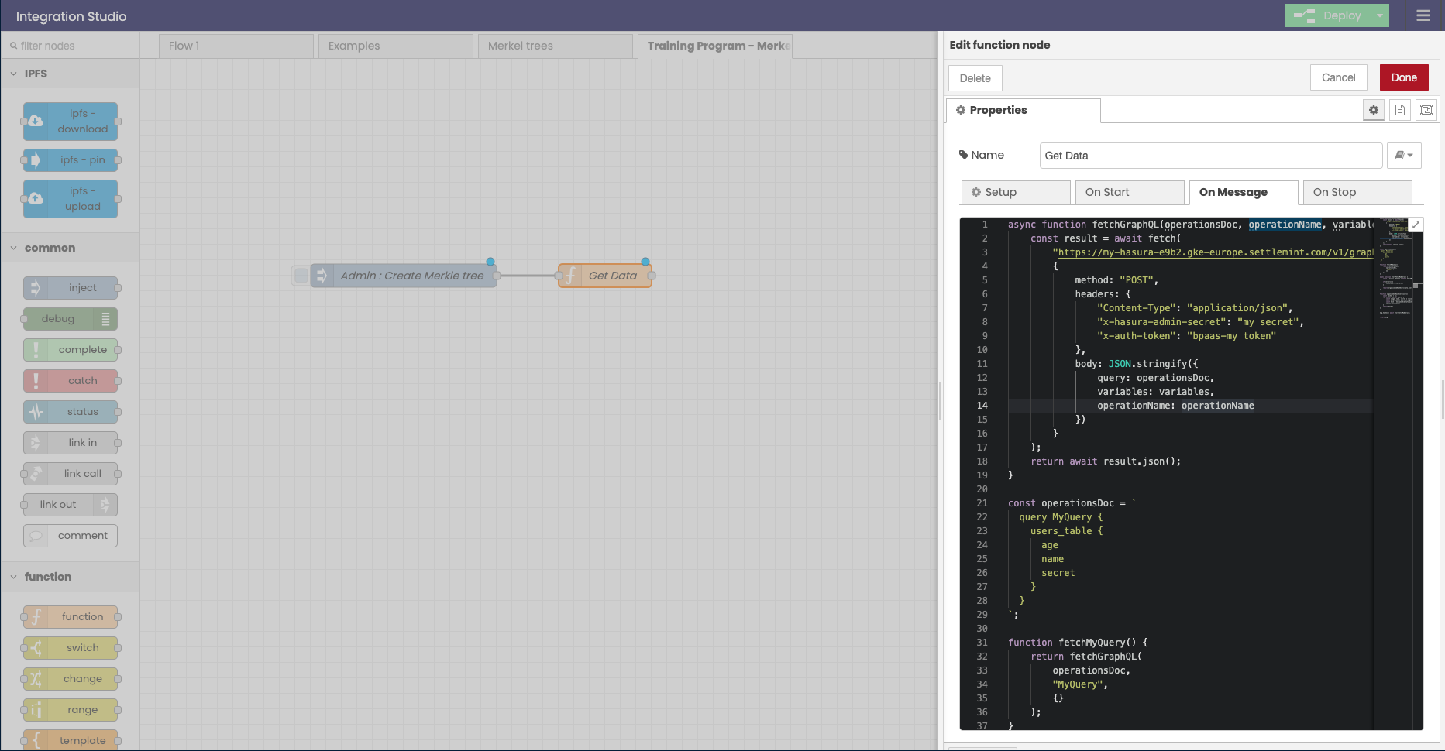

2.3 ADDING DEBUG NODE:

To debug in integration studio you can add a debug node and ask it to log a value from the msg object , in this case its going to log the msg.hashes value which declared in the Get Data function node.

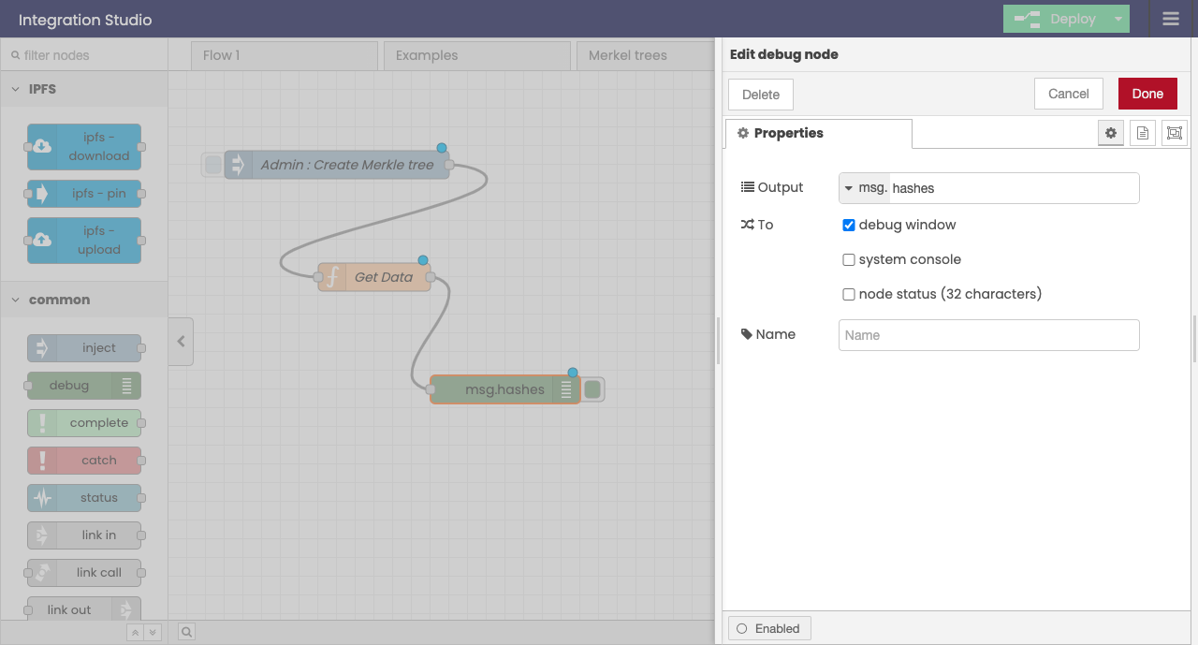

//Get Data function node

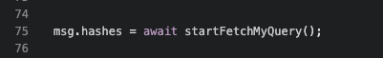

Now if you trigger this command, you should see in your debug console the hashes that were created form your Hasura DB.

[

'41bb1e44bc70ec73abff22e9968938cf52f18cfc15cd3cc28fa49873ed7d5a79',

'dce01d42480af923fab205a2e4291d4803291389410a084504b786e4fdcf8b61',

'4007e85b723e582d22cc6061558c51eaf16719a19ddb95a749f33375f6ee0080'

]

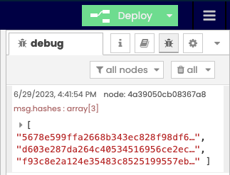

2.3 Generating the merkel tree and abstrcting the root hash

We don’t have to be cryptography masters to create merkel trees, we can use the libraries that run the algorithm for us.

To do so lets create a new function node and call it “Generate merkel tree” , we will create a tree and abstract from it the roothash we will store on chain,

And set the merkle tree it self and root hash as global variable so we will be able to call them from anywhere we want in our flows

Of course don’t forget to import the merkel JS module, and again the keccak256 to the new function node

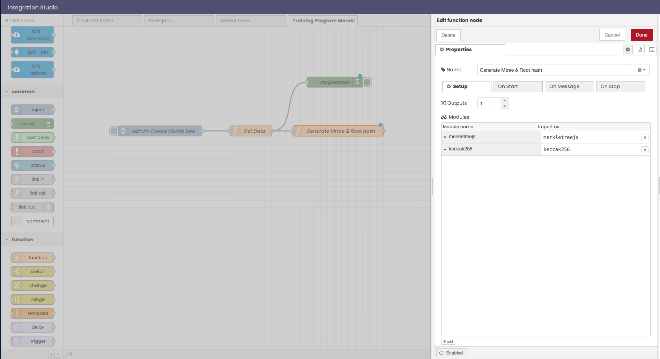

Now lets add to the this function node the following script,

const leaves = msg.hashes

// // Hash addresses to get the leaves

//let leaves = addresses.map(keccak256)

// // Create tree

let merkleTree = new merkletreejs.MerkleTree(leaves, keccak256, { sortPairs: true })

// // Get root

let rootHash = merkleTree.getRoot().toString('hex')

global.set("merkleTree", merkleTree);

global.set("rootHash", '0x' + rootHash);

msg.roothash = '0x' + rootHash

msg.mtree = merkleTree

return msg



This script takes the hashes that we generated in the previous function node (Get data) and inserts them into the merkel tree algorithm, and generates for us the merkel tree,

Then we use another built- in function in the merkeljs library to generate the root hash.

And finally we are initializing the root hash and the merkel tree as global variables,

And also adding them to the msg object

We will also add a couple of debugger nodes, one will logg the the entire merkel tree (msg.mtree = merkleTree)

msg.mtree



And the second will log the root hash (msg.roothash = '0x' + rootHash)

msg.mtree



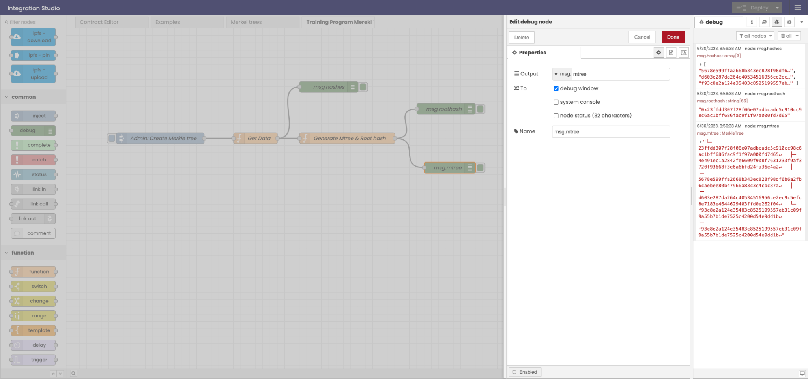

To check that everything is functioning as expected, lets add a couple of debugger nodes

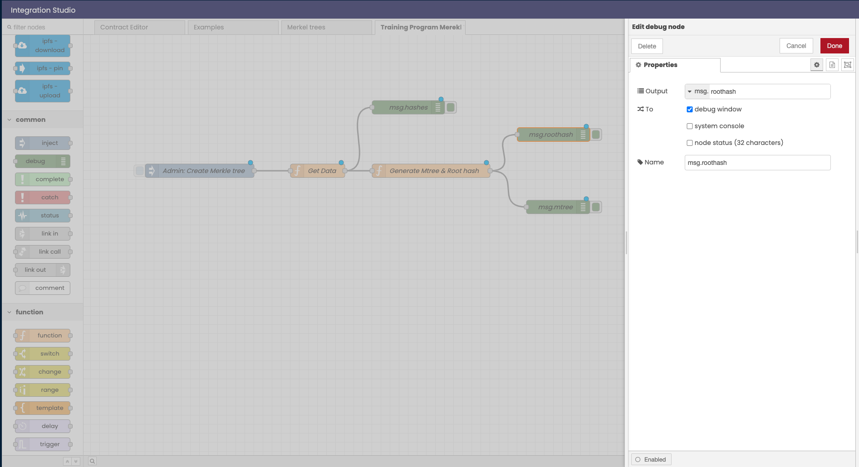

This is how our flow looks like so far

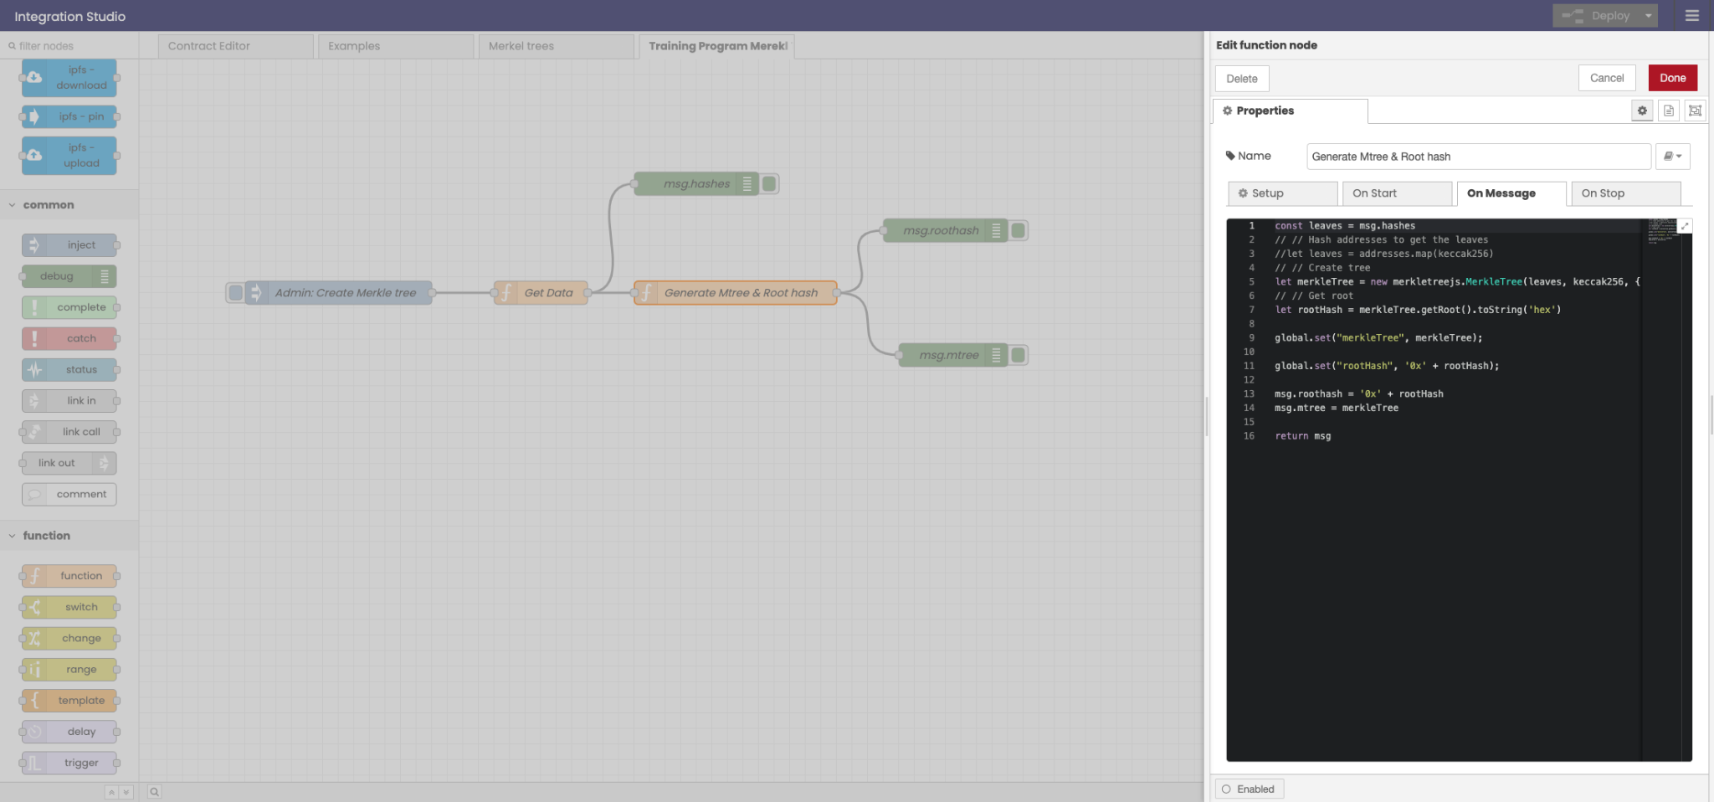

**3.Integration studio - users flow**

In the previous section we handled the admins flow, we created merkel tree using our database, we will later use the root hash of that tree

Now lets create a flow that will simulate a user, who is calling the contract.

The user inputs his “secret”, from the secret we call the rest of his information from hasura, and we then use the same method that we used in step 2 to create a hash,

Then we will be able to check against the root hash if our users hash belongs in that tree.

**3.1** create a new “Inject node”, double click it change it name “User: Verify against roothash” or anything else. Then press “add” to and add a new item and add to the msg object a userSecert (msg.userSecert) like the image below,

The value injected will be the secret, which we will use in a second to fetch the rest of the users data.

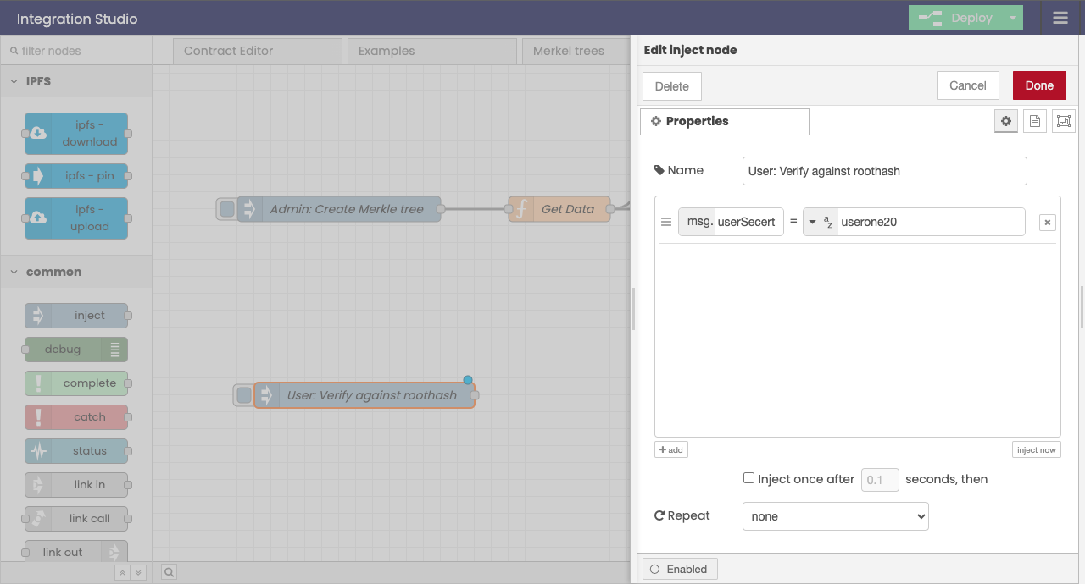

**3.2 adding Get Data function node.**

Next we are going to add to the users flow a new “Get Data” function node, this function node will operate just like the Get Data function node of the “Admin : create merkel “ but with one change, we are going to change the “operationDoc” variable ( the query), and input to it dynamically the msg.userSecert value that we input in the “User: Verify against roothash” “inject node” which we made in the previous section (3.1)

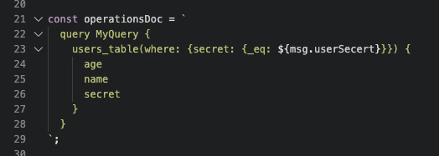

The full script would look like this, make sure that you input your own values, the best way would be to just copy the previous Get Data node, and change only the operation Doc variable .

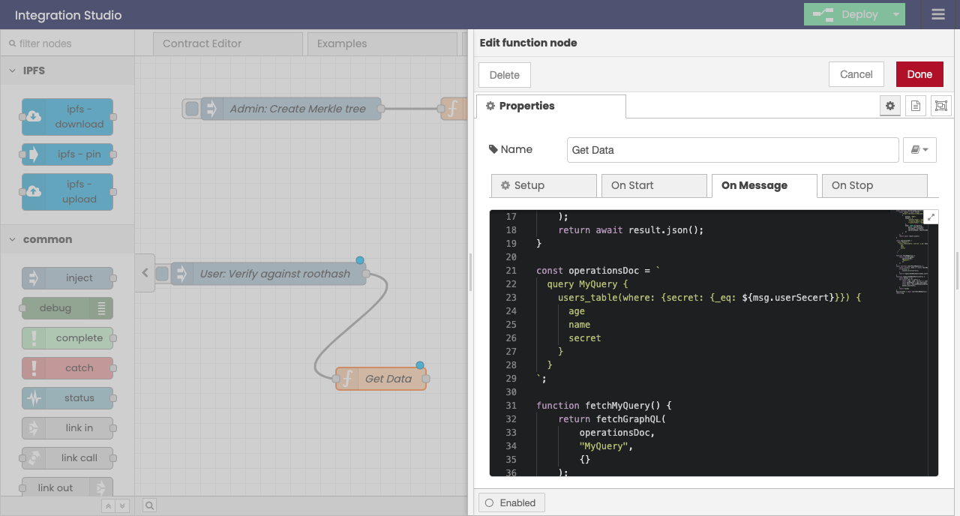

**3.3 Verifying**

Next let's create a function node that verifies the hash of the user against the root hash of the tree.

We can do so by adding a function node “verify” and adding to it the following code,



const leaf = await msg.userInfo[0]

const rootHash = await global.get("rootHash")

const merkleTree = await global.get("merkleTree")

const hexProof = merkleTree.getHexProof(leaf)

msg.proof = await hexProof;

msg.isVerfied = merkleTree.verify(hexProof, leaf, rootHash)

return msg;



The code gets the root hash and merkel tree that we create in the “admin flow” (step 2) And returns in the msg.isVerfied the status of the verification

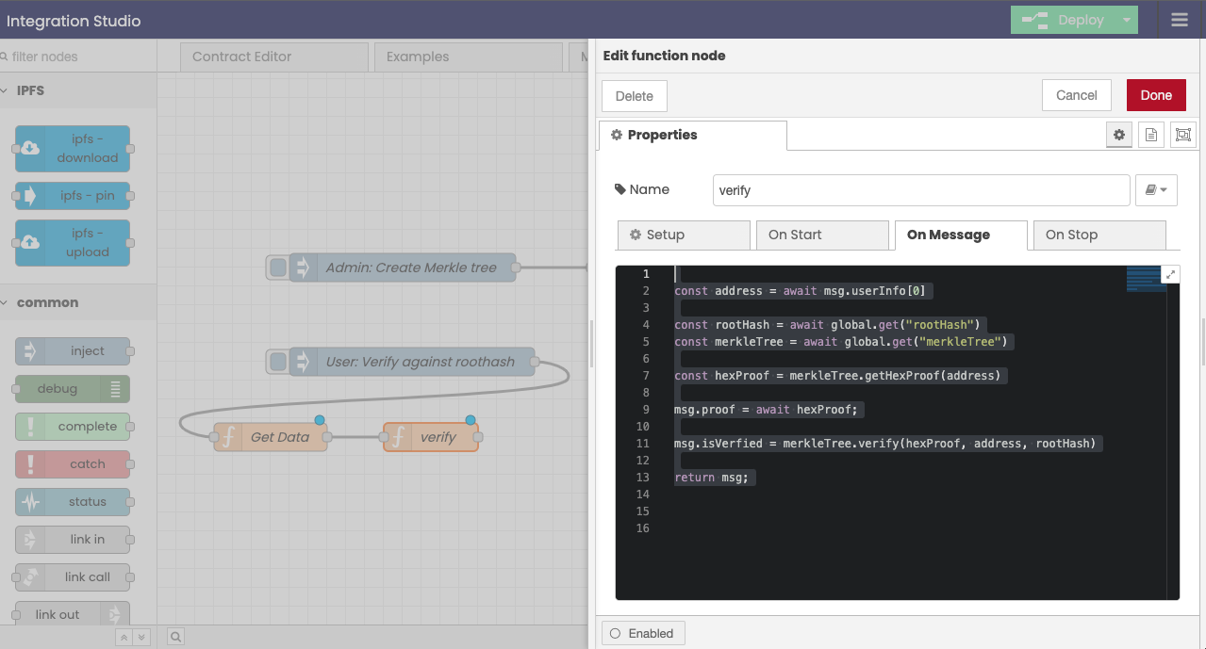

Then we will add a debug node that will log the “msg.isVerfied”

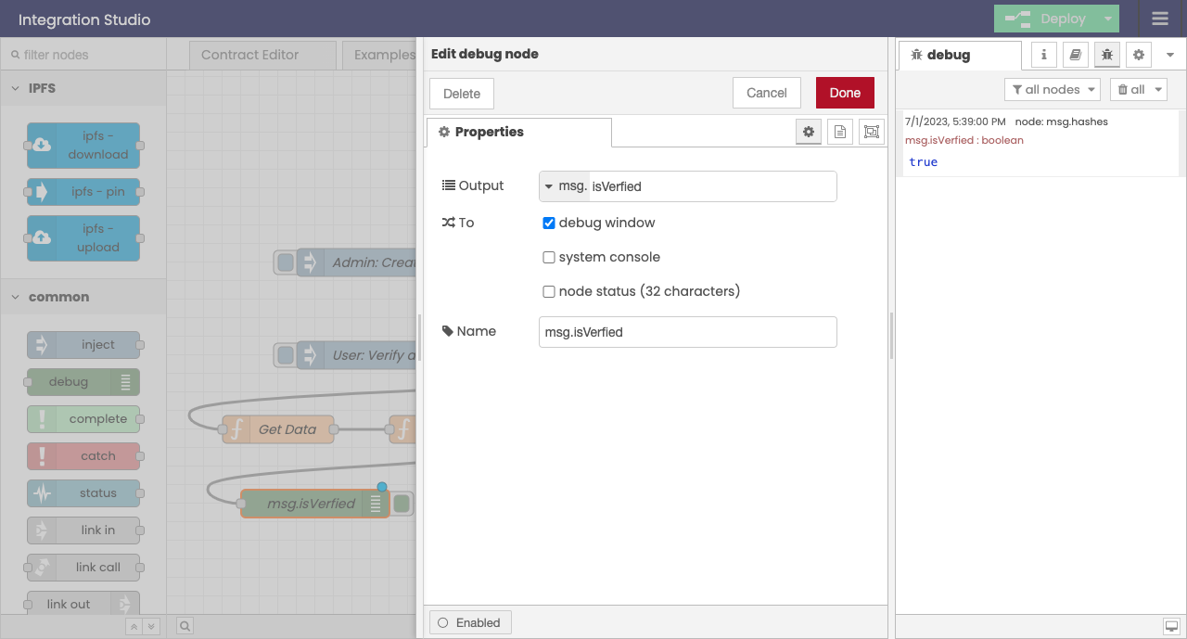

Of course this still does not verify anything again’t the blockchain,and so the next naturally the next step will be to deploy the smart contract!

4. The contract !

4.1 - writing the contract

Create a file in your Settlemint IDE in the contract folder,

Call it for example “**MerkleExample”** and copy in it the following contract

****// SPDX-License-Identifier: GPL-3.0

pragma solidity >=0.8.0 <0.9.0;

import "@openzeppelin/contracts/utils/cryptography/MerkleProof.sol";

contract MerkleExample {

bytes32 public rootHash;

constructor(bytes32 _rootHash) {

rootHash = _rootHash;

}

function checkValidity(bytes32[] calldata _merkleProof, bytes32 leaf) public view returns (bool) {

return MerkleProof.verify(_merkleProof, rootHash, leaf);

}

}

****

The smart contract functionally is to store the rootHash, therefore allowing our users to verify against the blockchain if their hash can be derived form the roothash.

Just like we import in integration studio the merkel js library in the smart contract we will import openZeppelins merkelProof library.

****import "@openzeppelin/contracts/utils/cryptography/MerkleProof.sol";

****

We will store the root hash in a bytes32 state variable

** public rootHash = 0x000000000000000000000000000000000000000000000000000000000000000000000;**

****

Just like the Verify function node in the previous section,

The contract calls the Merkel tree library to prefrome the verification, note that it accepts the same parameters but in a different order

**MerkleProof.verify(_merkleProof, rootHash, leaf)**

**  
4.2 Deployment script**

Create a new deployment script in the deploy folder with the following syntax (00_name.ts)

Replace the argument with the roothash that your admin flow creates and deploy the contract

****import { DeployFunction } from 'hardhat-deploy/types';

const func: DeployFunction = async function (hre) {

const { deployments, getNamedAccounts } = hre;

const { deploy } = deployments;

const { deployer } = await getNamedAccounts();

await deploy('MerkleTest', {

from: deployer,

args: ["REPLACE WITH ROOTHASH!"], // replace with your rootHash

log: true,

});

};

export default func;

func.tags = ['MerkleTest'];

****

to deploy it run

**** npx hardhat deploy --network <network-name> --tags MerkleTest

****

**5.Lets test it!**

5.1 Set up the smart contract interface by copying over the ABI and contract address to the contract editor flow.

5.2 run the “get proofs” command, and check the information in the contract interface

5.3 if the function returned true it means that you made it! Congrats! Now you know how to whitelist any information you would like on the blockchain without exposing it. Nad you are ready to take the next challenge

6. !task - Upgrade:

Add “addPoints” function, which checks if the user is verified, and if it is it adds a point to that user each time he calls that function.

Hint : map the points to addresses

### Cross Chain bridge - atomic swaps

**Task Description: Implement Cross-Chain Atomic Swaps using keccak256 Hash**

**Objective: Your task is to implement a system for performing cross-chain atomic swaps. This should be implemented using two Ethereum smart contracts, one for each chain involved in the swap.**

**Steps:**

* **Secret Generation: Generate a secret and its corresponding hash. The secret should be a pseudo-random number generated within a smart contract. Use the keccak256 function to generate a hash of the secret.**
* **Contract Deployment on Chain A:**
  + **Write a contract in Solidity that represents the initiation of the atomic swap.**
  + **The contract should hold the assets to be swapped. For simplicity, you can use the native currency of the chain (Ether for Ethereum) for this task.**
  + **The contract should contain the hash of the secret in its constructor, and a function that allows the participant on Chain B to claim the funds if they can provide the secret that matches the stored hash.**
  + **This contract should also specify the participant on Chain B, and only this participant should be able to claim the funds.**
  + **Deploy this contract on Chain A.**
* **Contract Deployment on Chain B:**
  + **Write a similar contract for Chain B.**
  + **This contract should also hold assets, contain the hash of the secret, and specify the participant from Chain A.**
  + **Deploy this contract on Chain B.**
* **Secret Revelation and Swap Confirmation on Chain B:**
  + **The participant from Chain A should call a function on the contract on Chain B to confirm the swap. This function should require the secret as a parameter, and should release the funds to the participant from Chain A if the provided secret matches the stored hash.**
  + **If the secret is correct, the contract should emit an event with the secret to confirm the swap.**
* **Swap Confirmation on Chain A:**
  + **The participant from Chain B, now having the secret from the transaction on Chain B, should call a function on the contract on Chain A to confirm the swap.**
  + **Again, if the secret is correct, the contract should release the funds to the participant from Chain B and emit an event with the secret to confirm the swap.**

**Deliverables:**

* **Source code for the contracts deployed on both Chain A and Chain B.**
* **Detailed comments in the code explaining the functionality.**
* **Instructions on how to deploy and interact with these contracts using a tool like Remix or Truffle.**
* **Tests demonstrating the atomic swap process, including both successful swaps and failed swaps due to an incorrect secret. These tests can be written in JavaScript using a testing library like Mocha and should be run against a local Ethereum blockchain like Ganache.**

**Remember, the goal of this task is to ensure that the swap is atomic - either both asset transfers happen, or neither do. Good luck with your implementation!**

### Simplified ENS - Domain name space

**Task: Building a Simplified ENS (Ethereum Name Service) System**

**Overview:**

**In this task, you will build a simplified version of the Ethereum Name Service (ENS) system. ENS allows users to register and resolve human-readable names (domains) to Ethereum addresses. This task will give you hands-on experience in building a basic domain registration and resolution system using smart contracts and JavaScript.**

**Requirements:**

* **Basic understanding of Ethereum, smart contracts, and JavaScript.**
* **Development environment with Solidity compiler, Hardhat, and Node.js installed.**
* **Basic knowledge of Hardhat and Ethereum development tooling.**

**Steps:**

* **Project Setup:**
  + **Settlemint IDE**
  + **Integration studio**
  + **blockchain node deployed**
* **Contract Development:**
  + **Create a new Solidity contract file, e.g., ENS.sol, and define the contract with the required functions and data structures.**
  + **Implement the logic for domain registration and resolution:**
    - **Design the data structure to store domain-to-address mappings.**
    - **Write a function to register a domain by associating it with an Ethereum address.**
    - **Write a function to resolve a domain to its associated Ethereum address.**
  + **Compile and deploy the contract using Hardhat.**
* **ts Interaction:**
  + **Create a new Typescript file, e.g., ens.ts, to deploy the contract**
  + **Set up the necessary connections to an Ethereum network provider using ethers.js.**
  + **Write JavaScript functions to perform the following actions (can be done in integration studio)**
    - **Register a domain by calling the contract's register function.**
    - **Resolve a domain by calling the contract's resolve function.**
    - **Send a transaction to the resolved address using the resolved address as the recipient.**
  + **Test the functionality of your JavaScript code using Hardhat's testing framework or a separate test script.**

**Additional Tips:**

* **Break down the tasks into smaller steps, and explain each step thoroughly to provide beginners with a clear understanding of what they need to do and why.**
* **Encourage participants to ask questions and seek help if they encounter any difficulties.**
* **Provide additional resources and references for further learning about ENS, smart contracts, and Ethereum development.**

**Note: This is a simplified task to help beginners understand the basic concepts of an ENS system. In a real-world scenario, building a complete and secure ENS system would involve more complex considerations and features.**

**Feel free to modify the task based on your specific requirements and the level of expertise of the participants**

### Bouns task 1 : **Building a Decentralized Voting Application**

**Overview:**

**In this task, you will build a decentralized voting application using Ethereum smart contracts and JavaScript. The application allows users to create polls, vote on different options, and view the results in a transparent and tamper-proof manner.**

**Requirements:**

* **Solid understanding of Ethereum, smart contracts, and JavaScript.**
* **Development environment with Solidity compiler, Hardhat, and Node.js installed.**
* **Basic knowledge of Hardhat and Ethereum development tooling.**

**Steps:**

* **Project Setup:**
  + **Set up a new project in your settlemint application**
  + **make sure you have a blockchain node deployed**
* **Contract Development:**
  + **Create a new Solidity contract file, e.g., Voting.sol, and define the contract with the required functions and data structures.**
  + **Implement the logic for creating polls, voting on options, and tracking the results:**
    - **Design the data structures to store poll information, options, and votes.**
    - **Write functions to create a poll, vote on an option, and retrieve the poll results.**
  + **Compile and deploy the contract using Hardhat.**
* **typescript/ javascript Interaction:**
  + **Create a new file/ integration studio flow, to interact with the deployed contract.**
  + **Set up the necessary connections to an Ethereum network provider using ethers.js.**
  + **Write JavaScript functions to perform the following actions:**
    - **Create a new poll by calling the contract's createPoll function.**
    - **Vote on an option in a poll by calling the contract's vote function.**
    - **Retrieve the results of a poll by calling the contract's getResults function.**
  + **Test the functionality of your JavaScript code using Hardhat's testing framework or a separate test script.**

**Additional Tips:**

* **Consider adding additional features to the voting application, such as time-limited polls, multiple-choice questions, or weighted voting.**
* **Encourage participants to explore additional security considerations, such as preventing multiple votes from the same address.**
* **Provide participants with sample scenarios or use cases to guide them in creating meaningful polls for their application.**

### Bonus task 2 : **Building a Decentralized Voting Application**

**Task 2: Developing a Decentralized Crowdfunding Platform**

**Overview:**

**In this task, you will develop a decentralized crowdfunding platform using Ethereum smart contracts and JavaScript. The platform enables project creators to create crowdfunding campaigns, receive contributions from backers, and release funds upon successful completion of the campaign.**

**Requirements:**

* **Solid understanding of Ethereum, smart contracts, and JavaScript.**
* **Development environment with Solidity compiler, Hardhat, and Node.js installed.**
* **Basic knowledge of Hardhat and Ethereum development tooling.**

**Steps:**

* **Project Setup:**
  + **Set up a new project in your settlemint application**
  + **make sure you have a blockchain node deployed**
* **Contract Development:**
  + **Create a new Solidity contract file, e.g., Crowdfunding.sol, and define the contract with the required functions and data structures.**
  + **Implement the logic for creating campaigns, contributing to campaigns, and releasing funds:**
    - **Design the data structures to store campaign details, contributions, and funding goals.**
    - **Write functions to create a campaign, contribute to a campaign, and release funds upon campaign completion.**
  + **Compile and deploy the contract using Hardhat.**
* **JavaScript /typescript Interaction:**
  + **Create a new file/ integration studio flow, to interact with the deployed contract.**
  + **Set up the necessary connections to an Ethereum network provider using ethers.js.**
  + **Write JavaScript functions to perform the following actions:**
    - **Create a new crowdfunding campaign by calling the contract's createCampaign function.**
    - **Contribute funds to a campaign by calling the contract's contribute function.**
    - **Release funds from a completed campaign by calling the contract's releaseFunds function.**
  + **Test the functionality of your JavaScript code using Hardhat's testing framework or a separate test script.**

**Additional Tips:**

* **Consider adding additional features to the crowdfunding platform, such as stretch goals, campaign updates, or refund mechanisms.**
* **Encourage participants to think about campaign verification and dispute resolution mechanisms.**
* **Discuss the advantages of decentralized crowdfunding, such as reduced fees, global accessibility, and increased transparency.**

**Feel free to modify the tasks according to your preferences and the skill level of the participants. Add any specific requirements or constraints as needed.**